

***Perfect Fitness Online System***

**user requirement documents**

Document Information and Revision History

|  |  |  |  |  |
| --- | --- | --- | --- | --- |
| Version | Date | Author(s) | Student number(s) | Revision notes |
| 5.1 | 17/03/2014 | Beni | H00181266 |  |
|  |  | Dane | H00181255 |  |
|  |  | Irene | H00181273 |  |
|  |  | Daniel | H00181275 |  |
|  |  | Kgomotso | H00184417 |  |

Table of Contents

1. **Project Diary…………………………………………………….………………………...1-20**
2. **USER REQUIREMENTS DOCUMENT...............................................................21-36**
3. **Project Plan…………..…………….…………………………………………………….37**-47
4. **Risk Management Plan………………………….……………….………………….…48**-54
5. **Cost Management Plan…………………………………………………………………55**-62
6. **GUI…………………………………………………………………………………………63-68**
7. **Curriculum Vitae………………………………………………………………………..69-77**
8. **Design Report…………………………………………………………………………….78-92**
9. **Implementation report…………………………………………………………………93-98**
10. **User Manual…..………………………………………………………………………..99-116**
11. **Operations and Maintenance………………………………………………………117-125**
12. **Project Evaluation-----------------------------------------------------------------------------126-134**
13. **COST MANAGEMENT PLAN ACCEPTANCE………………………….…………135**

**Document Status sheet**

|  |  |
| --- | --- |
| **Document title:** | **User requirement for a Fitness Club** |
| **Document status:** | **Commercial in confidence/ draft 1** |
| **Copyright** | **© 2014 System Software Development** |

|  |  |  |  |
| --- | --- | --- | --- |
| **Version** | **Authors** | **Date** | **Reason for change** |
| Fitness club URD_v0.0.1_draft001.doc | Group 3 | 17/02/2014 | Document creation |
|  |  |  |  |
|  |  |  |  |
|  |  |  |  |
|  |  |  |  |

|  |  |  |  |  |
| --- | --- | --- | --- | --- |
| **Issue** | **Authors** | **Date** | **Developers signature** | **Customer’s signature** |
| Fitness club URD_v0.0.1_draft001.doc | Group 3 | 26/02/2014 |  |  |

1. **Project Diary**

**Project Log**

**Introduction**

The project log contains all the progress, problems and issues that happened during the development of the project.

**Purpose**

The purpose of the project log was to document all the issues, problems and progress that happened during the development of the project.

|  |  |  |  |
| --- | --- | --- | --- |
| Issue ID | Date | Assigned | Description |
| # 1 | Tuesday 11/02/2014 | (Project Manager)  Beni | Project plan and assign team responsibility |
| # 2 | Friday 14/02/2014 | Beni | Start creating GUI’s |
| # 3 | Monday 17/02/2014 | Project team | Meeting with clients |
| # 4 | Tuesday 18/02/2014 | Dane | Starts with user requirements diagram |
| # 5 | Wednesday 19/02/2014 | Irene | Starts the cost management plan |
| # 6 | Monday 24/02/2014 | Kgomotso/Daniel | Starts the risk management plan |
| # 7 | Tuesday 25/02/2014 | Irene/Beni | Starts the project plan |
| # 8 | Wednesday 26/02/2014 | Beni | Finished creating GUI’s |
| # 9 | Saturday 08/03/2014 | Dane | Finished the user requirement diagram |
| # 10 | Tuesday 11/03/2014 | Irene/Beni | Finished the cost management plan |
| # 11 | Tuesday 11/03/2014 | Daniel/Kgomotso | Finished the risk management plan |
| # 12 | Saturday 08/03/2014 | Irene/Beni | Finished the project plan |
| # 13 | Tuesday 01/04/2014 | Project team | Meeting with clients |
| # 14 | Wedneday 02/04/2014 | Dane | Starts sprints for URD |
| # 15 | Wednesday 02/04/2014 | Irene | Starts sprints for cost plan |
| # 16 | Wednesday 02/04/2014 | Kgomoto/Daniel | Starts sprints for risk plan |
| # 17 | Wednesday 02/04/2014 | Irene/Beni | Starts sprints for project plan |
| # 18 | Monday 19/05/2014 | Dane | Finished Sprints for URD |
| # 19 | Tuesday 20/05/2014 | Irene | Finished Sprints for cost plan |
| # 20 | Tuesday 20/05/2014 | Kgomoto/Daniel | Finished sprints for risk plan |
| # 21 | Tuesday 20/05/2014 | Irene/Beni | Finished sprints for project plan |
| # 22 | Monday 09/06/2014 | Beni | Completed Website |
| # 23 | Tuesday 10/ 06/2014 | Beni | Meeting with client |
| # 24 | Tuesday 10/06/2014 | Beni | C# Program |
| # 25 | Tuesday 10/ 06/2014 | Irene | Starts with database |
| # 26 | Saturday 14/06/2014 | Irene/Beni | Completes database |
| # 27 | Monday 16/06/204 | Beni | Meeting with clients |
| # 28 | Monday 22/07/2014 | Beni | Makes changes to program |
| # 29 | Thursday 24/07/2014 | Dane | Updates user requirement diagram |
| # 30 | Friday 25/07/2014 | Irene | Updates cost plan |
| # 31 | Saturday 26/07/2014 | Kgomotso and Daniel | Update risk plan |
| # 32 | Tuesday 05/08/2014 | Irene | Updates project plan |
| # 33 | Tuesday 12/08/2014 | Beni | Changed C# program to visual basics |
| # 34 | Wednesday 13/08/2014 | Project Team | Meeting with clients |
| # 35 | Tuesday 09/09/2014 | Irene | Starts project implementation report |
| # 36 | Wednesday 10/09/2014 | Irene | Completes project implementation report |
| # 37 | Friday 12/09/2014 | Irene | Updates project implementation report |
| # 38 | Wednesday 15/10/2014 | Beni | Starts User Guide |
| # 39 | Thursday 16/10/2014 | Beni | Completes user guide |
| # 40 | Friday 17/10/2014 | Beni | Completes user guide sprints |
| # 41 | Wednesday 15/10/2014 | Kgomotso | Starts operations and maintenance guide |
| # 42 | Thursday 16/10/2014 | Kgomotso | Completes operations and maintenance guide |
| # 43 | Friday 17/10/2014 | Kgomotso | Completes operations and maintenance guide sprints |
| # 44 | Wednesday 15/10/2014 | Daniel | Starts project Evaluation report |
| # 45 | Thursday 16/10/2014 | Daniel | Completes project Evaluation report |
| # 46 | Friday 17/10/2014 | Daniel | Completes project Evaluation report |

**Conclusion**

All tasks will be completed and received by both client and lecturer before the due date of 26 August 2014.

**Status report**

**Introduction**

The following status report contains accomplished tasks for previous months and TO DO’s for the current month.

**Accomplishments**

* Had a meeting with the client

When : 17 february 2014

By : Entire project team

* Completed GUI for web site

When : 21 february 2014

By :Beni

* Completed User requirements document

When : 08 March 2014

By : Dane

* Completed cost management plan

When : 11 March 2014

By : Irene/Beni

* Completed risk management plan

When : 11 March 2014

By : Daniel/Kgomotso

* Completed project management plan

When : 08 March 2014

By : Irene/Beni

* Completed Architectural overview

When : 30 April 2014

By : Irene

* Completed GUI final design

When : 01 May 2014

By : Beni

* Created template for database

When : 08 March 2014

By : Kgomotso/Beni

* Completed Data flow charts

When : 10 May 2014

By : Kgomotso

* Completed Use case diagrams

When : 10 May 2014

By :Dane

* Completed UML diagrams

When : 18 May 2014

By :Beni/Daniel

* Completed spints for Use requirement documents

When : 19 May 2014

By : Dane

* Completed sprints for risk register plan

When : 20 May 2014

By : Kgomotso/ Daniel

* Completed sprints for cost mangement plan

When : 20 May 2014

By : Irene/Beni

* Completed sprints for project mangement plan

When : 20 May 2014

By : Irene/Beni

* Completed sprints for Architectural overview

When : 20 May 2014

By : Irene

* Completed Project Implementation

When: 15 October 2014

By : Irene

* Completed User Guide

When: 15 October 2014

By: Beni

* Completed Operations and Maintenance Guide

When: 15 October 2014

By: Kgomotso

* Completed Project Evaluation

When: 15 October 2014

By: Daniel

**TO DO:**

* Filling in database

Estimated amount of time: 5 hours

By : Irene

When: 04 August 2014

* Update the use requirement document

Estimated amount of time: 2 hours

By : Dane

When: 09 August 2014

* Update cost management plan (Bank Reconciliation)

Estimated amount of time: 2 hour

By : Irene

When: 09 August 2014

* Update the risk register plan

Estimated amount of time: 2 hours

By : Kgomotso

When: 09 August 2014

* Complete register page and log in

Estimated amount of time: 3 hours

By : Beni

When: 09 August 2014

* Complete and update key functions in the program such as Kiosk application, managing trainers application, program page, Transaction records, membership types as well as types of reports.

Estimated amount of time:10 hours

By : Beni

When: 19 August 2014

* Complete linking MS Access to C#

Estimated amount of time: 1hours

By : Beni

When: 20 August 2014

* Complete web site

Estimated amount of time: 2 hours

By : Beni

When: 21 August 2014

* Complete program

Estimated amount of time: 2 hours

By : Beni

When: 21 August 2014

* Project Implementation

Estimated amount of time: 4 hours

By : Irene

When: 15 October 2014

* User Guide

Estimated amount of time: 5 hours

By: Beni

When: 15 October 2014

* Operations and Maintenance Guide

Estimated amount of time: 3 hours

By: Kgomotso

When: 15 October 2014

* Project Evaluation

Estimated amount of time: 5 hours

By: Daniel

When: 15 October 2014

**Description**

Equipment and material needed are common stationary(Book/Pen) and laptops or any other computer device with applications such has MS Word, MS Access, C#.

**Conclusion**

All tasks will be completed and received by both client and lecturer before the due date of 26 August 2014

**Sprint**

**Sprints (Cost management plan)**

Dates (February/March)

|  |  |  |  |  |  |  |  |  |  |  |  |  |  |  |  |  |  |  |  |  |  |  |  |  |  |  |  |  |  |  |
| --- | --- | --- | --- | --- | --- | --- | --- | --- | --- | --- | --- | --- | --- | --- | --- | --- | --- | --- | --- | --- | --- | --- | --- | --- | --- | --- | --- | --- | --- | --- |
|  | Tasks | 19 | 20 | 21 | 22 | 23 | 24 | 25 | 26 | 27 | 28 | 1 | 2 | 3 | 4 | 5 | 6 | 7 | 8 | 9 | 10 | 11 | 12 | 13 | 14 | 15 | 16 | 17 | 18 | 19 |
| 1 | Cost breakdown structure | 2 | 2 | 2 | 2 | 1 | 1 | 1 | 1 | 2 | 3 | 0 | 0 | 0 | 0 | 0 | 0 | 0 | 0 | 0 | 0 | 0 | 0 | 0 | 0 | 0 | 0 | 0 | 0 | 0 |
| 2 | Cost assumptions | 1 | 3 | 2 | 1 | 3 | 1 | 1 | 2 | 0 | 0 | 0 | 0 | 0 | 0 | 0 | 0 | 0 | 0 | 0 | 0 | 0 | 0 | 0 | 0 | 0 | 3 | 1 | 1 | 0 |
| 3 | Cost Schedule | 1 | 1 | 1 | 1 | 1 | 1 | 1 | 0 | 0 | 0 | 0 | 0 | 0 | 0 | 0 | 0 | 0 | 0 | 0 | 0 | 0 | 0 | 0 | 0 | 0 | 0 | 0 | 1 | 0 |
| 3 | Budget | 3 | 3 | 2 | 2 | 1 | 0 | 0 | 0 | 0 | 0 | 0 | 0 | 0 | 0 | 0 | 0 | 0 | 0 | 0 | 0 | 0 | 0 | 0 | 0 | 0 | 2 | 1 | 1 | 0 |
|  | Total | 7 | 9 | 7 | 6 | 6 | 3 | 3 | 3 | 2 | 3 | 0 | 0 | 0 | 0 | 0 | 0 | 0 | 0 | 0 | 0 | 0 | 0 | 0 | 0 | 0 | 5 | 2 | 3 | 0 |

**Goal**

The goal of the cost management plan is to view the overall cost and estimates of the Perfect fitness club system such as to identify the cost involved in terms of equipment, hardware, software etc. that the Perfect fitness club system will be in need of.

**Burndown (Cost management plan)**

**Sprints (Project management plan)**

Dates (February/March)

|  |  |  |  |  |  |  |  |  |  |  |  |  |  |
| --- | --- | --- | --- | --- | --- | --- | --- | --- | --- | --- | --- | --- | --- |
|  | Tasks | 25 | 26 | 27 | 28 | 1 | 2 | 3 | 4 | 5 | 6 | 7 | 8 |
| 1. | Project charter | 3 | 1 | 3 | 4 | 0 | 0 | 0 | 0 | 0 | 0 | 0 | 0 |
| 2. | Scope management | 2 | 2 | 2 | 2 | 0 | 0 | 0 | 0 | 0 | 2 | 1 | 0 |
| 3. | Change control management | 1 | 0 | 0 | 0 | 0 | 0 | 0 | 0 | 1 | 2 | 2 | 0 |
| 4. | Schedule/Time management | 3 | 2 | 3 | 3 | 2 | 2 | 1 | 0 | 0 | 0 | 0 | 0 |
| 5. | Milestones | 2 | 0 | 0 | 0 | 0 | 0 | 0 | 0 | 0 | 0 | 1 | 0 |
| 6. | Quality management | 1 | 0 | 0 | 0 | 0 | 0 | 0 | 0 | 1 | 1 | 1 | 0 |
| 7. | Human resource management | 2 | 4 | 5 | 1 | 3 | 0 | 0 | 0 | 0 | 0 | 1 | 0 |
| 8. | Procurement management | 1 | 0 | 0 | 0 | 0 | 0 | 0 | 0 | 0 | 0 | 2 | 0 |
|  | Total | 15 | 13 | 13 | 10 | 5 | 2 | 1 | 0 | 2 | 5 | 8 | 0 |

**Goal**

The goal of the project plan is to determine the starting and ending point of the project; to identify the responsibilities of each member in the project team and to highlight any problems that we might encounter during the making of the system as well as to help manage risk.

**Burndown (Project management plan)**

**Sprints (System architectural overview)**

Dates (April)

|  |  |  |  |  |  |  |  |  |  |
| --- | --- | --- | --- | --- | --- | --- | --- | --- | --- |
|  | Tasks | 1 | 2 | 3 | 4 | 5 | 6 | 7 | 8 |
| 1. | Architectural representation | 1 | 0 | 0 | 0 | 0 | 0 | 0 | 0 |
| 2. | Architectural goals and constraints | 1 | 1 | 0 | 0 | 0 | 0 | 1 | 0 |
| 3. | Logical view | 3 | 4 | 1 | 0 | 0 | 0 | 0 | 0 |
| 4. | Deployment view | 1 | 0 | 0 | 0 | 0 | 0 | 0 | 0 |
| 5. | Implementation view | 2 | 3 | 0 | 2 | 3 | 1 | 1 | 0 |
| 6. | Data view | 0 | 0 | 0 | 0 | 0 | 1 | 1 | 0 |
| 7. | Size and performance | 0 | 0 | 0 | 1 | 1 | 0 | 0 | 0 |
|  | Total | 8 | 8 | 1 | 3 | 4 | 2 | 3 | 0 |

**Goal**

The goal of the architectural overview is to provide a complete overview of the system, using a number of different architectural views to show different aspects of the perfect fitness online system.

**Burndown (System architectural overview)**

**Sprint of the User Requirement Document**

**Goal**

The goal of the User Requirement Document sprint is to illustrate the tasks that are being done in the URD, and estimating how long each task will take and providing data as accurate as possible.

**Sprint Backlog of the User Requirement Document**



**Risk management sprint**

|  |  |  |  |  |  |  |  |  |  |  |  |  |  |  |  |  |  |  |  |
| --- | --- | --- | --- | --- | --- | --- | --- | --- | --- | --- | --- | --- | --- | --- | --- | --- | --- | --- | --- |
|  | Estimation to hours assigned to task | Feb |  |  |  |  |  |  | Mar |  |  |  |  |  |  |  |  |  |  |
| Tasks |  | 22 | 23 | 24 | 25 | 26 | 27 | 28 | 01 | 02 | 03 | 04 | 05 | 06 | 07 | 08 | 09 | 10 | 0 |
| 1.Risk Identification | 4 | 1 | 0 | 0 | 0 | 1 | 1 | 0 | 0 | 0 | 0 | 0 | 0 | 0 | 0 | 0 | 0 | 0 | 0 |
| 2.Risk Identification methods | 4 | 0 | 0 | 0 | 0 | 0 | 0 | 0 | 0 | 1 | 0 | 2 | 0 | 0 | 0 | 0 | 0 | 0 | 0 |
| 3.Risk analysis | 3.5 | 0 | 0 | 0 | 0 | 0 | 0 | 0 | 0 | 0 | 1 | 1 | 1 | 0 | 0 | 0 | 0 | 0 | 0 |
| 5.determining severity | 3.5 | 0 | 0 | 0 | 0 | 0 | 0 | 0 | 0 | 0 | 0 | 0 | 0 | 1 | 2 | 0 | 0 | 0 | 0 |
| 6.Risk Register | 4 | 0 | 0 | 0 | 0 | 0 | 0 | 0 | 0 | 0 | 0 | 0 | 0 | 0 | 0 | 1 | 2 | 2 | 0 |
|  | Total: 10 hours |  |  |  |  |  |  |  |  |  |  |  |  |  |  |  |  |  |  |

**Goal**

The goal of the this sprint is to identify the how much time was taken to complete the task that were associated with the risk plan .This will provide useful data that will then tell us whether the time spent on a task was underestimated or over estimated .

**Burn down chart**

**Sprints (Project implementation report)**

Dates (October)

|  |  |  |  |  |
| --- | --- | --- | --- | --- |
|  | Tasks | 13 | 14 | 15 |
| 1. | Methodologies | 1 | 0 | 0 |
| 2. | Achievements of action | 0 | 1 | 0 |
| 3. | Changes | 0 | 1 | 0 |
| 4. | Project issues | 0 | 0 | 1 |
| 5. | Lessons learned | 0 | 0 | 1 |
|  | Total | 1 | 2 | 2 |

**Goal**

The goal of this report is to evaluate the state of implementation of the project, the respect of the work plan, the methodologies used for the project and whether the project's objectives have been achieved.

**Burndown (Project implementation report)**

**Sprints (Project User Guide)**

Dates (October)

|  |  |  |  |  |  |
| --- | --- | --- | --- | --- | --- |
|  | Tasks | 14 | 15 | 16 | 17 |
| 1. | General information | 1 | 0 | 0 | 0 |
| 2. | System summary | 1 | 0 | 0 | 0 |
| 3. | Getting started | 0 | 2 | 0 | 0 |
| 4. | Exit system | 0 | 1 | 1 | 0 |
| 5. | Using the system | 0 | 0 | 2 | 0 |
| 6. | Reporting | 0 | 0 | 1 | 1 |
|  | Total = 10 | 2 | 3 | 3 | 1 |

**Goal**

The goal of the user guide document is to provide guidelines on how to use the system in case a user encounters a problem or is unsure about a certain function(s).

**Burndown (Project User Guide)**

1. **User Requirement Documents**

**INTRODUCTION**

**Purpose**

The purpose of this document is to describe the user requirements for the fitness club in a clear and consistent manner as requested by the customer .The system will record membership sales and subscriptions with all the individual fitness routines for the members of the fitness club, thus allowing an overview of the running of the fitness club.

The readers of this document will be the customer and the developers, System Software Development.

It is intended to be read by:

1. The manager of the fitness club, so that he knows what system he is getting;

And

1. System Software Development as developers, so they know what to develop.

**Scope**

There is one software System which is – the Fitness Club Database. The scope of this project is a fully functional stand-alone application for the website. The system includes a website and database.

The database will store the following:

* Personal details of the customers that have a membership at the fitness club.
* Membership registration.
* Sale of food supplements, diet foods, and fitness equipment.
* Fitness plans for members and targets in the plans.
* Statistical information on effectiveness of the club.

The main purpose of this database is to give an overview of the running of the fitness club and record member’s details with their personal fitness information. This database will enable the client to easily see how the fitness club is running regarding member satisfaction and sales.

**Definitions, acronyms and abbreviations**

**Abbreviations**

|  |  |
| --- | --- |
| Stats | Statistics |
| F-UR | Functional User Requirement |
| NF-UR | Non-Functional User Requirement |
| HTTP | Hypertext Transfer Protocol |
| PC | Portable Computer |

**Definitions**

|  |  |
| --- | --- |
| Technogym | A company that provides perfect fitness with their fitness machines. |
|  |  |
|  |  |

**Acronyms**

|  |  |
| --- | --- |
|  |  |
|  |  |

**References**

1. RD_1- Author M.Farrow, Medical Database Systems Ltd: Commercial in confidence <http://www.macs.hw.ac.uk/~monica/Modules/S1/SoftEng3/URD/ExampleURD.pdf>
2. RD_2- W3C CSS Standards - http://www.w3.org/TR/CSS1/

**Overview**

This document is structured according to the standard described in [RD_1]. It is divided into two main sections namely: User requirements and System requirement.

Chapter 2 provides a general description of the fitness club. It describes the software for the fitness club, the general capabilities, general constraints, user characteristics, operational environment and assumptions.

**GENERAL DESCRIPTION**

**Product Perspective**

The product is for the use of the manager, staff, members, personal trainers and potential members of the fitness club. The members of the club will be able to interact with the system but they will be constraint to their fitness plan and progress of their plan against their goals.

The administrator will be able to perform special changes in the database if it is needed as well as look after the website.

This project is intended to achieve overall effectiveness about the fitness club by providing essential information to the fitness club.

Admin

**Product Scope Diagram**



Club database

Browse data

Update data

System



Club Management System

Member and personal trainer

 

Update data

Query data

Update data

Browse data

Non-member user

Web site

 

Manager

Browse data

Request data

Update data



Generate Report

**General capabilities**

The fitness club software is a database whereby the manager and staff of the fitness club can update, insert, delete and select information from the database. The members of the fitness club have access to their personal fitness plan, goals and they can update their sessional data regarding their session performance. The non-members are only allowed to browse the website.

These are the main functional requirements:

1. Allow the staff to record details of the members, this includes payment of subscription.
2. Allow staff to record sales of food supplements, diet foods and fitness equipment to members.
3. Allow personal trainers to record fitness plans for members and to maintain an updated sessional record of member’s progress in their plan against their goals, and provide the manager with review reminder for plan.
4. Maintain statistical information on the performance of members against their fitness plans.
5. Produce statistics on usage levels, additional member spending and membership levels.

**Use Case Diagram**

Record member details

Generate report

Maintain staff details

Manager



Record payment details



Record sales

Review reminder for plan

Staff

Record fitness plans

Personal trainer



Maintain stats of members

**Allow staff to record details of the members, including payment of subscription**

Data is entered for a new member when the customer wants to register with the fitness club. Everything from address, date of birth, health details and statistics are added to the database of the system. The payment of subscription will be recorded as well and that will produce an annual membership subscription request.

The staff will identify members by their name, so a search for an existing member will be by surname. From this search a list will come up and when the member is selected it will illustrate the member’s details.

Annual bill

Record payment of subscription

Add Member Details

Search a member

Delete member details

Update member details

Staff Manger

 

Search all members’ detail

Add as member

**Allow staff to record sales of food supplements, diet foods and fitness equipment to members**

Members of the fitness club can purchase food supplements, diet food and fitness equipment. When a purchase is made the data will be processed and stored on the database as well as this purchase will form part of the member record on the database, so that the fitness club can keep a record of the purchases done from which members. At the end of each month the manager will be able to see how much profit is made and which members bought what regarding sales in the fitness club.

Form part of member record

Record sale of supplements

Record sale of diet foods

Staff



Record sale of fitness equipment

**Allow personal trainers to record fitness plans and maintain updated sessional record for members**

Members will be given a fitness plan, whether it is for mass gaining, weight loss or toning of the body, these fitness plans will be stored on the fitness club database under each members name. A sessional record of member’s progress will be updated and put against their goals every session on the database. From that information a review reminder for plan will be given to the manager after every 5 completed sessions of that member. Using this sessional information a change plan will be created.

Update member fitness plan

Delete member fitness plan

Add Member fitness plan

Personal trainer Manager

 

Update member progress

Print review after every 5 sessions

Generate review reminder for plan

**Maintain statistical information on the performance of members against their fitness plans**

All information about the member regarding their progress and performance of reaching their goals will be extracted from the database and used to show statistical information against their fitness plans, to show their progress as well as the effectiveness of the club.

Maintain stats of performance of members

Generate stats on usage levels

Manager



**Produce statistics on usage levels, additional member spending and membership levels**

All automated machines and non-automated machines in the fitness club will be checked every 4 weeks and each automated machine will be serviced after every 5000km that machine has done. All the automated machines have a built in system that records all the information and when a check-up is needed the Technogym company login into that machine using their own machines to check the data of that machine. That data will be given to the staff to produce stats on usage levels. When members sign up with perfect fitness, they have an option to choose what membership levels they want. These membership levels are regarding when they are allowed to enter and use the facility.

Produce stats of usage levels

Provide membership levels

Staff



Provide additional membership spending

**General Constraints**

A SQL database will be used to store personal information of fitness club members and their fitness plans and progress, statistics, record of sales. Members will have to log into the site with their username and password to gain access to their fitness plans, statistics and progress of their goals. If members have admin rights, the member will be able to update and edit information. The statistics, progress of members and sales done at perfect fitness will be back up on a regularly basis for data loss reasons.

Non-member users will be able to view the site but not be able to log into the database. When an administrator is logged into the database, the site should provide functions like, adding, updating and inserting data.

The quality of the fitness club system is constrained by the presence of the deadlines and the amount of time the project team has available to complete the project.

Any data inserted into the database will be validated and verified before going on to the database.

**User characteristics**

The users of the database will be the following:

* The manager of the fitness club.
* Staff of the fitness club
* Members of the fitness club
* Non-members users
* Personal trainers of the fitness club

The database will be used routinely every day because data will be coming in every day and tasks will be performed and reports will be produced using the data. Insertion, delete, update and adding will be done on a daily basis.

**Operational environment**

The database will be run on a network where PC’s are connected to this network and are able to communicate with each other and it is not blocked by any firewall like HTTP. These PC’s will be using Microsoft windows 7 and it will be created using Microsoft Access.

**Assumptions and dependencies**

The assumption is that the environment in which the testing will take place is available during the development and testing stage of the project. We assume that there will be an interface for the implementation and we assume that there will be 5 skilled people working together on the project. We assume that there will be enough space for all the PC’s that need to be set up as well as network instruments.

With the assumption of 8000 members walking into the gym per month, perfect fitness on average should produce about R300 000 net profit.

The dependencies are that the network layout diagram needs to be completed before we can start setting up the network for the fitness club. The cost and risk plan needs to be done in order for the project to go ahead and start purchasing equipment needed.

**SPECIFIC REQUIREMENTS**

**Capability requirements**

F-UR 1 **Allow staff to record details of the members, including payment of subscription**

**Need: Essential Priority: Phase 1 Source: Manager of the Perfect Fitness**

F-UR 1-1 Add a new member

Staff and manager should be able to add a new member into the database. This will include all personal details like: address, date of birth, health details, statistics and medical aid scheme. The registration form should be completed.

F-UR 1-2 Delete member details

Staff and manager shall be able to delete a member from the database if he/she is not at the fitness club anymore.

F-UR 1-3 Update member details

Staff and manager shall be able to update details of a member at the fitness club, if he/she has details that need to be changed.

F-UR 1-4 View member details

Staff and manager shall be able to search for a member on the system by their surname. Members can be searched further by their address, and all the details for the member shall be displayed.

F-UR 1-5 Record payment of subscriptions

Staff and manager shall be able to record the payment of subscription which will produce an annual membership subscription request.

F-UR 2 **Allow staff to record sales of food supplements, diet foods and fitness equipment to members**

**Need: Essential Priority: Phase 2 Source: Manager of the Perfect Fitness**

F-UR 2-1Record sale of supplements

Staff shall be able to record the sale of food supplements in the fitness club and the supplements bought by the member must be recorded on the system.

F-UR 2-2 Record sale of diet foods

Staff shall be able to record the sale of diet foods in the fitness club and the diet foods bought by the member must be recorded on the system.

F-UR 2-3 Record sale of fitness equipment

Staff shall be able to record the sale of fitness equipment in the fitness club and the fitness equipment bought by the member must be recorded on the system.

F-UR 3 **Allow personal trainers to record fitness plans and maintain updated sessional record for members**

**Need: Essential Priority: Phase 3 Source: Manager of the Perfect Fitness**

F-UR 3-1 Add Member fitness plan

Staff shall be able to record individual fitness plans for members and those fitness plans should be represented graphically. The fitness plans should be able to be printed for the member.

F-UR 3-2 Delete member fitness plan

Staff shall be able to delete the fitness plan from the database if he/she is not using that fitness plan anymore.

F-UR 3-3 Update member fitness plan

Staff shall be able to update the fitness plan of the member if he/she would like to change his/her plan.

F-UR 3-4 Update member progress

Staff shall be able to update member progress against their goals/targets every session

F-UR 3-4 Generate review reminder for plan

Staff shall be able to produce a review reminder for plan for the manager after every 5 sessions of the member.

F-UR 4 **Maintain statistical information on the performance of members against their fitness plans**

**Need: Essential Priority: Phase 4 Source: Manager of the Perfect Fitness**

F-UR 4-1 Maintain stats of performance of members

Manager shall be able to keep and maintain the statistical information on the performance of the members against their fitness plans, to represent the effectiveness of the fitness club. The stats of the members at the fitness club should always be kept on the database and updated every session completed by the member.

F-UR 4-2 Generate stats on usage levels

The manager shall be able to produce statistics on usage levels and membership levels.

F-UR 5 **Produce statistics on usage levels, additional member spending and membership levels.**

**Need: Essential Priority: Phase 5 Source: Manager of the Perfect Fitness**

F-UR 5-1 Produce stats of usage levels

Staff shall be able to produce the statistics of the member’s progress using the information gathered over a certain period of time, in the database.

F-UR 5-2 Provide membership levels

Staff shall be able to provide membership levels regarding when they are allowed to enter and use the fitness club facility.

F-UR-5-3 Provide additional membership spending

Staff shall be able to provide additional membership spending, as this with help with the future planning and promotions.

**Constraint requirements**

**Hardware**

NF-UR1-1 The system shall be installed on the PCs in the managers’ office, the staffs’ office and the front desk PCs.

NF-UR1-2 The reports generated shall be printed on the network printer that is attached to the PCs.

NF-UR1-3 The system shall be installed by System Software Development.

**Software**

NF-UR2-1 The system shall be created using Microsoft Access 2010.

NF-UR2-2 Any faults in the software that has come up within the first 8 months after installation will be fixed free of charge.

**Data**

NF-UR3-1 The system shall be able to store 10000 members with approximately 200 items of data per member.

NF-UR3-2 The system shall not allow invalid data to be entered.

**Security**

NF-UR4-1 Managers and administrators will be the only user that will have access to all system functionality.

NF-UR4-2 Staff, members and personal trainers will have to input a username and password, which will determine the access level.

NF-UR4-3 Non-members won’t have access to the database, they will only be able to view the site.

**Reliability**

NF-UR5-1 The system shall not be accessible only when the system is down for maintenance and when there is no connection to the database.

**Legislation**

NF-UR6-1 The systems data shall meet the company’s privacy policies.

**Robustness**

NF-UR7-1 The fitness club system will recover from errors fast as possible.

**Usability**

NF-UR8-2 The system must be easy to learn, easy to understand, and easy to use.

1. **Project Plan**

**1. Introduction**

Purpose of the project plan

The purpose of this project plan is to determine the starting and ending point of the project; to identify the responsbilties of each member in the project team and to hightlight any problems that we might encounter during the making of the system as well as to help manage risk.

|  |  |
| --- | --- |
| *Aim* | The aim of this project is to implement an online system for the perfect fitness gym. |
| *Objectives* | * To automate the registering process * To save staff time * To reduce any type of error that might occur while registering * To have accurate information about customers |
| *What is the project?* | The project is about designing and implementing an online system that will keep record of memberships,sales and subscriptions, together with all individual fitness programs for members. |
| *Business need* | * To record individual fitness plans for members * Produce statistical information on the effectiveness of the club in helping customers achieve their goals * Ensure customer satisfaction at all times |
| *Deliverables* | The project will produce an online system that will capture all customers details, programs they are enrolled in as well as make known other facilities that the gym may have to offer. |
| *Cost* | R426 975 |
| *Roles & Responsibilities* | * Project manager ( Monitoring project) * Analyst (Analyzing project) * Programmer(Developing program) * Database designer(Designing the database) * Software tester(Testing of system ) * Documentation constructor(Creating of documentation) * Web designer(Designing of web site) |
| *Assumptions* | Interace will be web browser  System will access customer database  System can be accessed remotely |
| *Communication* | Meeting will take place every after 2 weeks to keep the customer up to date with the progression of the system |
| *Constraints* | * Project must be completed in 9 months: from February 2014 to October 2014 * Budget is * Must meet all the customers’ requirements * Must be tested thoroughly before handover to eliminate any problems |
| *Risks* | * Lack of relevant experience * Technology failure * Timescale risk: deliverable may be produced after project deadline * Cost risk: funding required to complete the project exceed the original budget |
| *Documentation* | Documentation will eb kept electronically in a database created for the project. |
| *Decision making process* | Project manager will identify the decisions and consult with the other stakeholders before final decisions are taken |
| *Signatures* | D forrester  K Hlabangwana  B Iyaka  I Kafalinji  D Kodiemoka |

|  |  |
| --- | --- |
| PROJECT | PERFECT FITNESS ONLINE SYSTEM |

|  |  |  |  |
| --- | --- | --- | --- |
| *Created by* | IM Kafalinji  B Iyaka | Date | 03 February 2014 |
| *Phone* | 011 345 6789 | Email | info@Perfectfitness.co.za |

# SCOPE MANAGEMENT

|  |  |
| --- | --- |
| Project aim and objectives | The aim of this project is to implement an online system for the perfect fitness gym.  • To automate the registering process  • To save staff time  • To reduce any type of error that might occur while registering  • To have accurate information about customers |
| Project constraints | * Project must be completed in 9 months: from February 2014 to October 2014 * Budget is * Must meet all the customers requirements * Must be tested thoroughly before handover to eliminate any problems |
| Assumptions | * Interface will be web browser * System will access customer database * System can be accessed remotely |
| Product requirements | * To record individual fitness plans for members * Produce statistical information on the effectiveness of the club in helping customers achieve their goals * Ensure customer satisfaction at all times |
| Project organisation | Every task that will be done during the project will be directly reported to the project manager for review and approval for the task completed.  The project will be projectised as a Matrix organisation in which members involved in the project have similar skills and are grouped together for work assignments resulting in one manager in each department. |
| Deliverables | The project will produce an online system that will capture all customers details, programs they are enrolled in as well as make known other facilities that the gym may have to offer. |
| Early risks | * Schedule Risks, not having enough resources * Cost risk, * Technical Risks, technology failure * Operational risks, |
| Authority and accountability | The project manager has the authority to make use of company resources to complete the project and make project day-to-day decisions but must report to the client for involvement in the project |
| Cost estimates | Cost baseline R336 975 |

*Work Breakdown Structure*

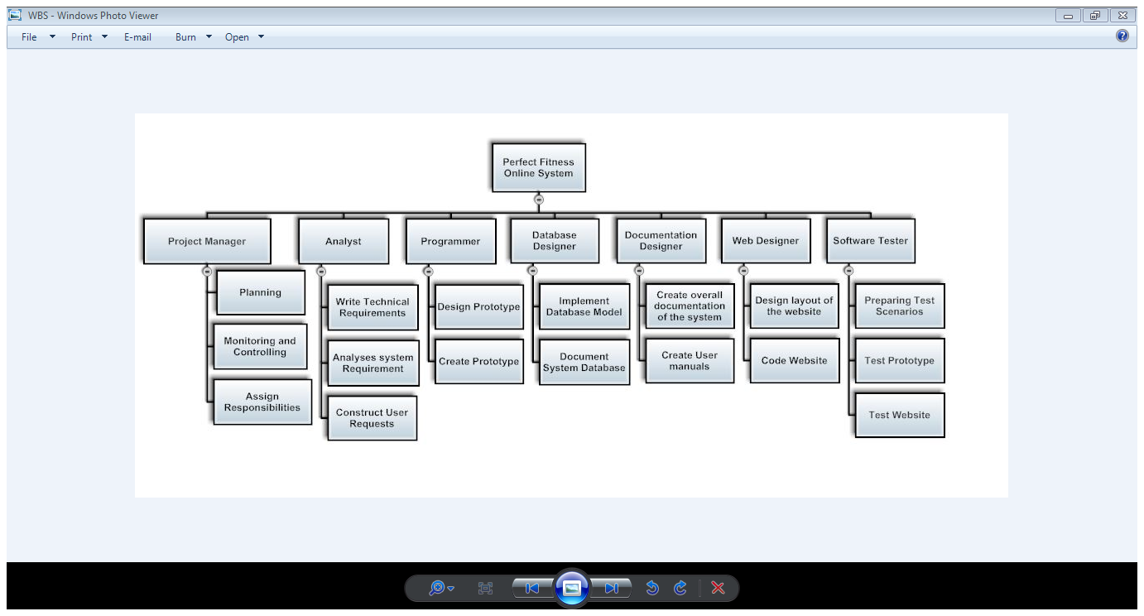

Change Control Management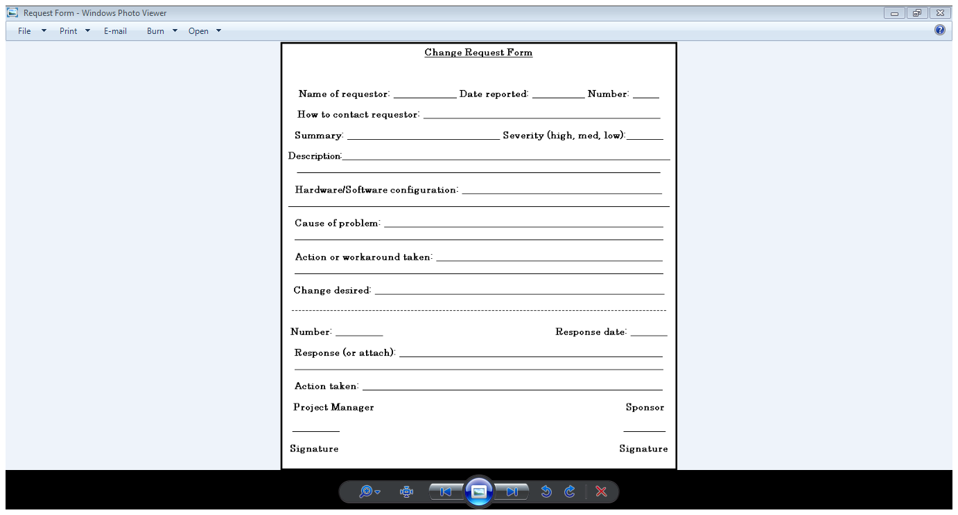

Schedule/Time Management

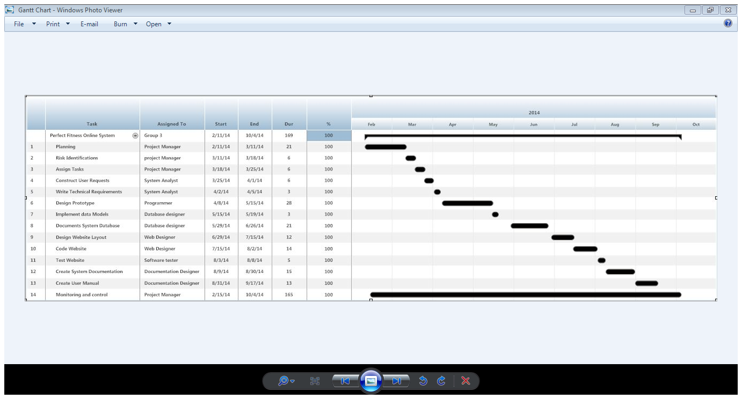

|  |  |  |
| --- | --- | --- |
| *Milestones* | *Date of Completion* | *Responsible person* |
| User requirements document | 26 February 2014 | Dane forrester |
| Cost management plan | 20 February 2014 | Irene Kafalinji/Kgomotso Hlabangwana |
| Risk management plan | 25 February2014 | Beni Iyaka/Daniel Kodiemoka |
| Graphic user interface | 03 March 2014 | Beni Iyaka |

*Milestones*

*Cost/Budget Management*

See Cost management Plan

# Quality Management

|  |  |
| --- | --- |
| *Quality objectives* | *Benefits* |
| Speed | The faster the system, the happier the customer shall be with its performances. |
| Reliability | The system should be able to produce accurate and correct results. |
| Security | No one should be ablte to hack into the system and have access to the database containing members personal information. |

*Human Resource Management*

|  |  |  |  |  |  |  |  |  |
| --- | --- | --- | --- | --- | --- | --- | --- | --- |
| *Activity/Task* | *Project manager* | *Analyst* | *Programmer* | *Database Designer* | *Documentation constructor* | *Wed designer* | *Software tester* | *Client* |
| Monitoring and controlling the project | R | I |  |  |  |  |  | C |
| test prototype | C | I |  |  |  |  | R | A |
| Write technical requirements | C | R |  |  |  |  |  | A |
| Design/create prototype | C | I | R |  |  | R |  | A |
|  |  |  |  |  |  |  |  |  |
| Implement the data models | C | R |  |  |  |  |  | A |
| Design and build relational database | C | I |  | R |  |  |  | A |
| Create documentation of system | C | I |  |  | R |  |  | A |
| Create user manuals | C | I |  |  | R |  |  | A |
| Design layout of website | C | I | R |  |  | R |  | A |
| Prepare test scenarios | C | I |  |  |  |  | R | A |
| Executing test case | C | I |  |  |  |  | R | A |

# Communications Management

See project chater(Communication)

# Risk Management

See risk management plan

# Procurement Management

*Contract type*

Time and materials type contract

*Sub- contractors*

Our sub-contractors will be technicans who will fix computers giving problems or that are not compatiable with the system once it is implemented.

|  |  |  |
| --- | --- | --- |
| *Document Name and Version* | *Description* | *Location* |
| Project Plan  Version 1.0 | To determine the starting and ending point of the project; as well as to identify the responsibilities of each member in the project. | http//:www.FitnessProjectPlan.co.za |

**Reference**

1. **Risk management plan**

**Introduction:**

The following document will address the possible risks that this project may face during the development stage .The purpose of this documents is to identify, control and plan the management of the projects risks.

|  |  |
| --- | --- |
| Risk Factor | Preventive measures |
| 1.Human error on part of staff | Employ the best people for the job .  Reward team members .  Team;  Formation;  Provide additional training .  Create contracts for all team members . |
| 2.Unrealistic schedule and budget | Create Business-case analysis reports .  encourage incremental development .  Update the schedule and budget as time progresses. |
| 3. Standard software external components (inexperience incompatibility etc.) | Create Prototypes ,  Apply benchmarking techniques .  Review of reference that are to be used .  Create a compatibility analysis  Provide a review of suppliers . |
| 4.Requirements and developed functions do not match | Come up with a win-won agreements with parties concerned .  Prototyping  Application description in early phase. |
| 5. User interface do not fit needs. | Prototyping ,  Create scenarios for development process .  Description of issues. |
| 6.Inadquate architecture ,performance ,quality | Create simulations .  Modeling,  Tuning of software. |
| 7.Constant alteration of requirements | Increase threshold for changes  Enforce Information hiding  Encourage incremental development ,  Change management process ,  Change control board. |
| 8.Problems with task performed externally | Design recovery.  Restructuring |
| 9.Problems with legacy | Audits parallel design or prototyping by several suppliers ,  Team formations |
| 10.Overestimation of own IT capabilities | Technical analysis  Cos/benefit analysis  Prototyping  Moderate teams performance and work quality .  Provide assistance with task if a team member is unable to execute . |
| 11. Availability and compatibility of software compiler used to developed the project | Keep software updated at all times .  Always have a secondary or alternative software compiler that can be used to execute the system .  Create restore points in case of a system failure(data recovery). |
| 12. Personality conflicts between member . | Create team building activities .  Deal with conflict at an early stage .  Encourage team members to focus on the project at hand . |

**Risk Register**

The following terms will be used to describe the type of impacts that might me encountered during the projects:

Catastrophic – This is the most highest impacts where by something tragic could happen with the project.

Major-Are considered the 2nd most highest impacts that the project could have .

Moderate-This would be the fair amount of an impact ,

Minor-The minimal impact that a project could have .

Negligible-The most trivial impact with the very least impact factor .

The following table will display the probability of occurrence prior to the risk ,and provide a value which will be associated with the definitions of occurrence .Values will be rated 1-5 where 1 being the least number of occurrence and 5 being the most number occurrences .

|  |  |  |
| --- | --- | --- |
| Probability of occurrence | | |
| Definition | Meaning | Value |
| Highly certain | *Will occur frequently  *will be experienced continuously until a preventative action is taken . | 5 |
| Most Likely | *Will occur less frequently . | 4 |
| Occasionally | *occurs every now and then . | 3 |
| Unlikely | *Unlikely to occur | 2 |
| Rare | *Highly unlikely to happen | 1 |

**Impact with Probability**

The following table will display the severity values which will determine the level of seriousness of the risk ,that could or would occur depending on the probability .

|  |  |  |  |  |  |
| --- | --- | --- | --- | --- | --- |
|  | Probability | | | | |
| Impact | 1 | 2 | 3 | 4 | 5 |
|  | Rare | Unlikely | Occasionally | Most Likely | Highly Certain |
| 5. Catastrophic | 5 | 10 | 15 | 20 | 25 |
| 4. Major | 4 | 8 | 12 | 16 | 20 |
| 3.Moderate | 3 | 6 | 9 | 12 | 15 |
| 2. Minor | 3 | 4 | 6 | 8 | 10 |
| 1. Negligible | 1 | 2 | 3 | 4 | 5 |

Very high –are values that would range from 15-25 .

High –Are probability values that range from 8-12 .

Medium-Are values that range from 4-6 .

Low –These values range from 1-3 that would least amount of probability that a risk would occur .

\***Red** means Very high risks (Severity risks), such risks are almost certain to happen and will happen.

\***Orange** means high risks, such risks are likely to happen and there are balances between severity and medium risks.

\***Yellow** means Medium risks, such risks can be minor or moderate risks and are possible risk that can occur or may never occur.

\***Green** means Low risk. This type of risks can be negligible, happens rarely and unlikely or occasionally .

|  |  |  |  |  |  |  |  |  |  |
| --- | --- | --- | --- | --- | --- | --- | --- | --- | --- |
| NO | Name | Type | Impact | Probability | severity | indicator | Risk plan | Pre strategy | Responses |
| 1 | Team members leaving the team . | Project Risk | Major | Most likely  (4) | 16 | *team member register documents | *Divide the work load equally among the remain team members .  *Consult the clients explaining situation and request a possible postponed deliverable date . | Bind team members to a strict contract . | Project leader |
| 2 | Unrealistic schedule and budget plan . | Project Risk | Major | Most Likely  (4) | 16 | *Cost plans and project plan reviews | *keep track of the daily progress rate .  * track of daily expenses .  *Restrict budget to essentials only . | *Provide weekly reviews of the cost baseline and budget .  *Allocate team members a time frame to complete a task . | Project manager |
| 3 | Performance of external task(the output rate of the system) . | Product Risk | major | Most likely  (4) | 16 | Logical errors with the software . | *Provide an upgrade for the system .solving old problems and creating new concepts . | *Create multiple testing scenarios . | Documenter |
| 4 | Overestimation of IT capabilities . | Project | Major | Most likely  (4) | 16 | *Review the quality and standard of teams work | *Use visual tutorials to help with development process . | *Conducting addition research . | Programmer |
| 5 | Miss match with requirement and function needs | Product Risk | Moderate | Occasionally  (3) | 15 | *when there would be a lack of communication with the client . | *Implement the concept of rapid application development to gain better understand of clients expectations | *Use the system development life cycle concept . | Analyst |
| 6 | Non satisfactory to user needs during the development stage . | Product Risk | Moderate | Occasionally  (3) | 12 | *Complaints of the systems restrictions | *Create prototypes of the logic and systems behavior .. | *Interview the end user to gain an in sight of their preferences | Project manager |
| 7 | Inexperience / user device and system incompatibility | Product Risk | Moderate | Occasionally  (3) | 9 | *A failure with installation process. | *Create more the than one compatibility possibilities . | *Research the compatibility requirements . | Database Developer |
| 8 | Legacy problems | Product Risk | major | Most likely  (4) | 8 | *complaints from user | *Apply the concept of rapid application design prior to the real life simulations of the system . | *Implement Prototypes of the system . | Documenter |
|  |  |  |  |  |  |  |  |  |  |
| 9 | Inadequate ,performance and quality of the product ect . | Product Risk | Moderate | Unlikely  (2) | 6 | *An early or regular failure of the software | *Create Simulations of how the system should work to gain better understanding .  *Constantly modify the software until it reaches to reach perfection . | . *Creation of prototypes that would simulate systems behavior .  *Compare the system with other existing systems that were developed with the best quality . | Analyst |
| 10 | Altering requirement | Product Risk | Moderate | Unlikely  (2) | 6 | *A constant change with the state of systems during development stage.  *System might not operate as intended to during the testing phase . | *Identify the key concepts of the with the requirements and strictly stick to those concepts while developing the system . | *Using encryptions on the system that is being developed .  *Encourage incremental development to keep track of all elements while they are still in their original state .. | Programmer |
| 11 | Personality conflicts between member . | Projects Risk | Negligible | Occasionally  (3) | 3 | *A lack of communication between some team members .  *Conflicts during the brainstorming phase . | *identify and address the team about the conflict .  *Give the team members an opportunity to have an input in other team members tasks . | *Given team members the opportunity to equally express their view prior to the project .  *Create team building activities . | Analyst |
| 12 | Availability and compatibility of software compiler used to developed the project . | Product Risk | Negligible | Occasionally  (3) | 3 | *not having the Compiler that supports the templates and tools needed for the application development . | *Use multiple mediums of software compilers to develop the application . *encourage other team members besides the programmer to participate in developer . | *Used only the basic development complier that had restrictions to some function . | Programmer |

A certain amount of money will be reserved to help deal with some of the risk that have been identified in the risk register .Risk that have a severity level from 8-25 will be financed in order for the risk to be depleted ,so that the project can become a success .

1. **Cost Management Plan**

Introduction

*1.1. Purpose of the Cost Management Plan*

The purpose of this cost management plan is to view the overall cost and estimates of the Perfect fitness club system such as to identify the cost involved in terms of equipment, hardware, software etc that the Perfect fitness club system will be in need of.

Project Manager Software Anti-Virus

Analyst Hardward Membeship Card Scanner, PCs

Programmer Consumable Member Card Updating the System

Database Designer Telephonic Support

**Training**

Software Tester Onsite Support

**Subcontractors**

Documentation Constructor

Web Designer

**Overheads**

User Manual

Trainer Technicals

Warranty Test Warranty Network

Repairs

Scanner

Telephone

Health

Replacement

Cost assumption

|  |  |  |  |
| --- | --- | --- | --- |
| Task | Work effect estimate | Cost per task | total |
| Project manager ( Monitoring project) | 30 | 250 | 7 500 |
| Analyst (Analysting project) | 60 | 250 | 15 000 |
| Programmer(Developing program) | 80 | 200 | 16 000 |
| Database designer(Designing the database) | 60 | 200 | 12 000 |
| Software tester(Testing of system ) | 30 | 100 | 3 000 |
| Documentation constructor(Creating of documentation) | 85 | 100 | 8 500 |
| Web designer(Designing of web site) | 70 | 150 | 10 500 |
| ***Total*** | 415 | 900 | R72 500 |

|  |  |  |  |
| --- | --- | --- | --- |
| *Labour* | *Unit cost* | *Quality(hrs)* | *Sub total* |
| ***WAGES*** |  |  |  |
| Project manager | R 250,00 | 70 | R 17 500 |
| System Analyst | R 250,00 | 60 | R 15 000 |
| Programmer | R 200,00 | 80 | R 16 000 |
| Database designer | R 200,00 | 60 | R 12 000 |
| Software tester | R 100,00 | 30 | R 3 000 |
| Documentation Designer | R 100,00 | 85 | R 8 500 |
| Web designer | R 150,00 | 70 | R 10 500 |
| TOTAL WAGES |  |  | R 82 500,00 |
| Benefits | 30% |  | R 24 750,00 |
| Overheads | 50% |  | R 12 375,00 |
|  |  |  | **R 119 625,00** |
| **EQUIPMENT** |  |  |  |
| **SOFTWARE** |  |  |  |
| Anti-virus | R 2 000,00 | 1 | R 2 000,00 |
| **HARDWARE** |  |  |  |
| Membership card scanner | R 5 000,00 | 1 | R 5 000,00 |
| PCs | R 6500 | 5 | R 32 500,00 |
| **CONSUMABLES** |  |  |  |
| membership cards | R 50,00 | 250 | R 12 500,00 |
| **TOTAL EQUIPMENT** | **R 13 550,00** |  | **R 52 000,00** |
|  |  |  |  |
| **INSTALLATION** |  |  |  |
| **TRAINING** |  |  |  |
| User manual | R 250,00 | 50 | R 12 500,00 |
| Training | R 500,00 | 4 | R 2 000,00 |
| Staff time | R 250,00 | 2 | R 500,00 |
| Warrantly cost | R 600,00 | 1 | R 6 00,00 |
| **TOTAL INSTALLATION** | **R 7 000,00** |  | **R 21 000,00** |
|  |  |  |  |
| **MAINTENANCE** |  |  |  |
| Updating the system | R 300,00 | 2 | R 600,00 |
| Telephonic support | R 200,00 | 2 | R 400,00 |
| Onsite support | R 750,00 | 3 | R 2 250,00 |
| **SUB -CONTRACTORS** |  |  |  |
| Technicians | R 400,00 | 2 | R 800,00 |
| Network | R 500,00 | 1 | R 500,00 |
| **TOTAL MAINTENCE** | **R 1 650,00** |  | **R 4 250,00** |

**Cost baseline R 196 875**

Project Reserve R 60 000

Management Reserve R 40 000

**Total Reserve Cost R 100 000**

Total Reserve Cost R 100 000

Markup R 153 125

Cost baseline R 196 875

**Total Project Price R 450 000**

Cost Budget

|  |  |  |  |  |
| --- | --- | --- | --- | --- |
| Month | Bought forward | Income | Expense | **Total** |
| February | 00.00 | R 17 500 | 00.00 | **R 17 500** |
| March | R 17 500 | R 17 500 | 00.00 | **R 35 000** |
| April | R 35 000 | R48 500 | R 2000 | **R81 500** |
| May | R 81 500 | R 37 500 | R 5000 | **R 114 000** |
| June | R114 000 | R 40 000 | R 32 500 | **R121 500** |
| July | R121 500 | R 28 000 | R12 500 | **R137 000** |
| August | R137 000 | R 29 000 | R14 500 | **R151 500** |
| September | R151 500 | R 26 000 | R500 | **R177 000** |
| October | R177 000 | R 19 975 | R1 300 | **R195 675** |

1. **Graphical User Interface**



This is the top part of the home page of the website. It consists of buttons which links you to different pages or information about the gym; at which when clicking on button:

* **02,** this will display information about Personal Trainers



* **03,** this will display information about the equipment found within the gym.



* **04,** this will display information about the group fitness program offered at the gym.

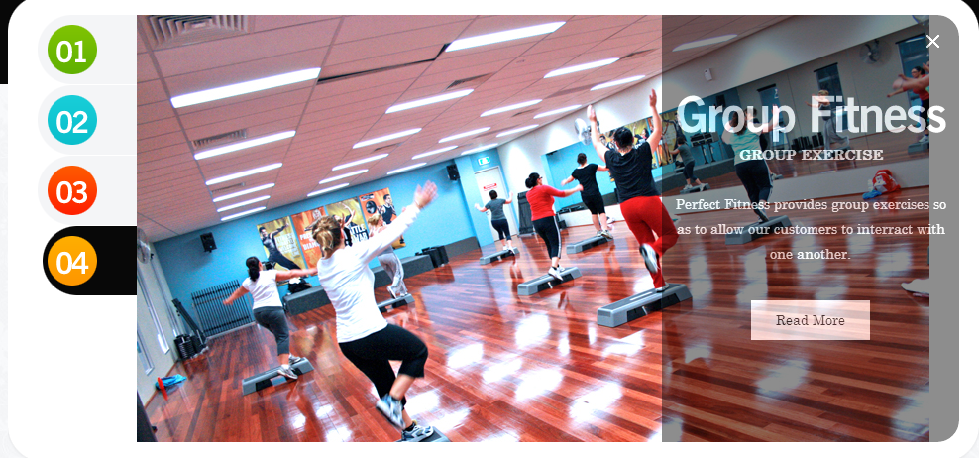

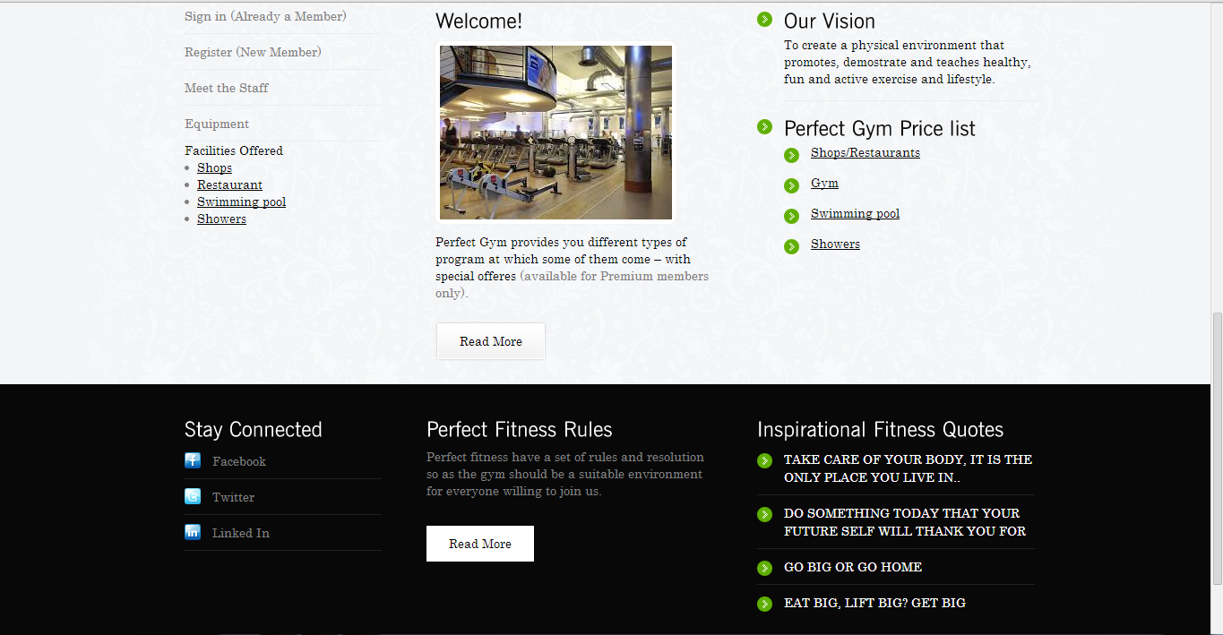

The bottom part of the page consist of links of downloading the prices of the items sold, information, and links to many other information related to programs offered at the gym.

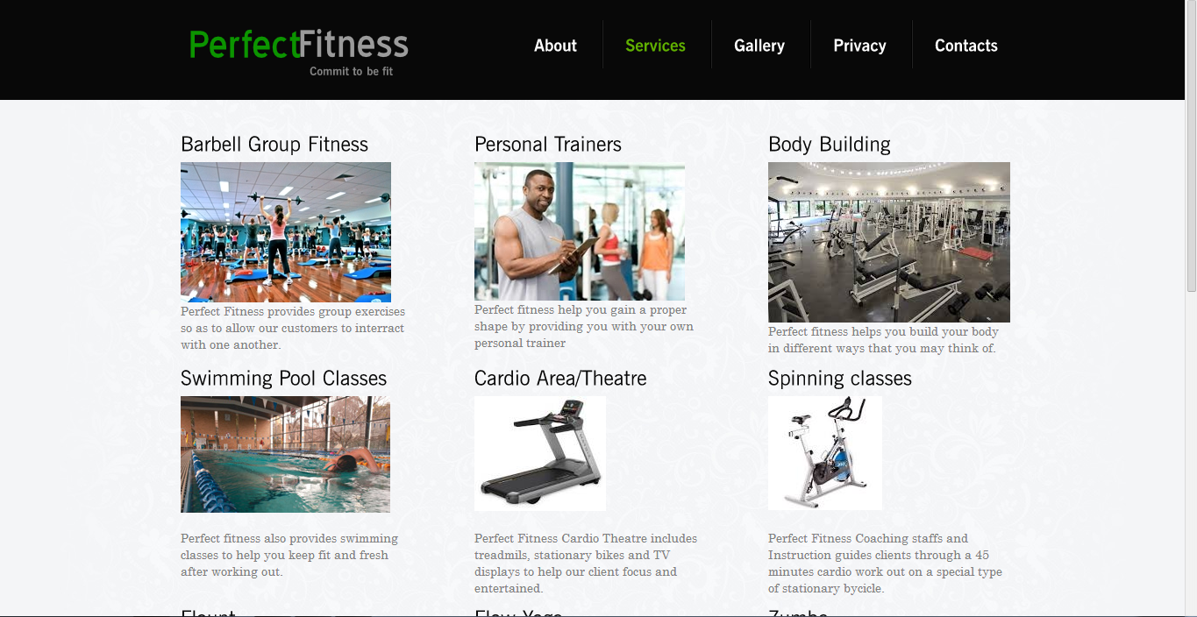



This is the second page of the website which displays the services offered at the gym and their descriptions.



This is the third page of the website and it displays some of the pictures.

1. **Curriculum Vitae**

**CURRICULUM VITAE**

**OF**

**Iyaka Beni**

**PERSONAL DETAILS**

SURNAME : Iyaka

FIRST NAME : Beni

DATE OF BIRTH : 1993/01/26

IDENTITY NUMBER (Refugee Status) : PTACOD400509

RESIDENTIAL ADDRESS : 35 York towers,

70 Hill brow Street, Berea

CONTACT NUMBER : 078 589 2724

GENDER : Male

MARITAL STATUS : Single

NATIONALITY : Congolese

HOME LANGUAGE : French

OTHER LANGUAGES : English

HEALTH STATUS : Excellent

HOBBIES : Music, Reading, Soccer

**EDUCATIONAL QUALIFICATION**

HIGH SCHOOL ATTENDED : Athlone Boys High School

SUBJECTS PASSED : Physical Science,

Mathematics, English,

Life science, life orientation,

Geography

Afrikaans first additional

HIGHEST GRADE COMPLETED : 12

YEAR : Class of 2011

**HIGHEST QUALIFICATIONS**

College/ University Attended : CTI Bedfordview/London School of

Business Management

EDUCATIONAL LEVEL : Diploma

Year of Completion (Diploma) : 2012 – 2013

**Key Skills**

* Html
* C#
* Java
* C++
* SQL

**WORKING EXPERIENCE**

NAME OF COMPANY : Melrows Park

TYPE OF WORK DONE : Waiter

Year of Work : 02/11/2012 – 05/01/2013

NAME OF COMPANY : Clientele Life

TYPE OF WORK DONE : Customer Care

Year of Work : 20/06/2008 – 12/12/2010

NAME OF COMPANY : Y3k IT Company

TYPE OF WORK DONE : IT Technician

Year of Work : 13/11/2013

NAME OF COMPANY : Anaconda Security

TYPE OF WORK DONE : Data Capturer

Year of Work : 01/11/2013 - 23/12/2013

**REFERENCES**

Mbongeni : 072 677 2770

Desmond Eliot : 083 356 4748

Darishen Naidoo : 082 784 6114

Mputi Mphahlele : 082 747 2083

**Dane Forrester**

**Personal details**

Address: 199 Bottlebrush drive

Bushwillow park estate

Greenstone

Telephone: 011609 5907

Cell Phone: 072 182 7180

Email: [6dane9@gmail.com](mailto:6dane9@gmail.com)

ID No: 8504165055085

Place of Birth/Nationality/: Edenvale / South African

Age: 28

**Education**

2000-2004 **Edenglen High School**

* Completed Matric in 2011
* Full colors in cricket

2005-2007 **CTI Education group**

* BTEC Higher National Diploma Information Technology
* 3 subject distinctions
* Bachelor of Science in Information Technology

**Skills**

* Communication skills
* Time management skills
* Leadership skills
* Technical skills
* Personal development skills
* C# skills
* System analysis
* HTML skills
* Documentation skills
* Data analysis skills

**Employment history**

* Worked part time at Baker street pharmacy (2006-2008)
* Worked at IT Specialists as project manager (2008-2010)
* Work at System Software Development (2010-2014)

**Notable Awards**

* Black belt in karate
* First team cricket captain

**Interests**

* Gym
* Playing golf
* Outdoor activities
* Enjoy watching sport
* Relaxing with friends and family
* Avid Animal lover

**References**

Nick Holthausen, Baker street pharmacy, Owner, 011 452 7831

*Curriculum vitae of Irene Kafalinji*

*Personal Goal:*

I strive to be an intelligent and diligent person, who will be considered a premier in her domain by proving that challenges can be done laboriously if you are a very resolute person, which I consider myself to be.

*Personal Details*

Surname : Kafalinji

Names : Irene Modieng

Date of Birth : 04 May 1993

Identity Number : 9305040561080

Nationality : South African

Marital Status : Single

Gender : Female

Home Language : Zulu

Other Language : English

*Contact Detail*

Residential : 17 Unity Street

New Modder

Benoni

1501

Contact Number : 083 749 3381

Email : IreneDbeauty@gmail.com

*Educational Information*

Secondary education : Benoni Educational College

Qualification : Grade 12

Year : 2011

Further education : CTI

Qualification : Higher National Diploma in Information Technology

Year : 2012-2013

Higher education : CTI Bedfordview Campus

Qualification : Bachelor of science in computer systems

Year : 2014

*Skills*

C#

Java

Information systems

Database management

Network Administration

Internet server management

Data structures and algorithms

Data Analysis and Design

Project management

Information systems analysis and design

*Interests*

* Being within the Business Analyst field.
* Subjects that interest me are Human computer interaction, Database management and Information system analysis and Design.

*Reference*

Name : Aaron Muzinda

Title : IT Lecturer

Organisation : CTI

Contact details : Tel : +27 76 320 5400

: Email : [Aaron.muzinda@gmail.com](mailto:Aaron.muzinda@gmail.com)

Name : Shepherd Mlambo

Title : IT Lecturer

Organisation : CTI

Contact details : Tel : +27 83 665 1392

: Email : [Shep.mlambo@gmail.com](mailto:Shep.mlambo@gmail.com)

**CURRICULUM VITAE**

**OF**

**Daniel Shako Kodiemoka**

**PERSONAL DETAILS**

SURNAME : Kodiemoka

FIRST NAME(S) : Daniel Shako

DATE OF BIRTH : 1991/08/02

IDENTITY NUMBER (Refugee Status) : 910802 6319 26 1

RESIDENTIAL ADDRESS : 155 saint Frusquin Street Malvern 2198

CONTACT NUMBER : 072 955 0780

GENDER : Male

MARITAL STATUS : Single

NATIONALITY : Congolean

HOME LANGUAGE : French

OTHER LANGUAGES : English

HEALTH STATUS : Excellent

HOBBIES : Music, Reading, Walking

**EDUCATIONAL QUALIFICATION**

HIGH SCHOOL ATTENDED : Kensington Secondary School

SUBJECTS PASSED : Physical Science, mathematics, English,

Life science, life orientation, Accounting

Afrikaans first additional

HIGHEST GRADE COMPLETED : 12

YEAR : Class of 2010

**HIGHEST QUALIFICATIONS**

Qualification Obtained : Higher National Diploma in

Information Technology

BSc Computer Systems : Completion of qualification in 2014

**WORKING EXPERIENCE**

NAME OF COMPANY : Melrows Park

TYPE OF WORK DONE : Waiter

Year of Work : 09/11/2012 – 28/12/2012

Name of Company : Y3K Technology

Type of Work Done : Server Manager

Year of Work : 2013

**REFERENCES**

Bongeni : 072677 2770

Darishen Naidoo : 082 784 6114

1. **Design Report**

*Purpose*

The purpose of this document is to provide a complete overview of the system, using a number of different architectural views to show different aspects of the perfect fitness online system.

*Scope*

This document applies to the overall design of the system. It contains information relating to the architectural design of the system, the Structure of the Database, and of the physical servers hosting the site.

*Overview*

This Document provides the reader with a deeper understanding of the design of the fitness club Website. It is organized into several views of the system, the *Logical view*, which will give an overview of the subsystems and components the system is comprised of, the *Deployment view,* explains how the system will be deployed and what it will be hosted on, the *Implementation view*, which will show how the system will be implemented and its network as well as its architectural setup, and the *Data view* which will show how the database is structured and organized.

# *Architectural Representation*

This perfect fitness online system was designed using a standard three tiered architecture, with a Presentation Tier, Application Tier and Data tier. The Presentation Tier contains all of the visible web pages and handles all input from and output to the users. The Application Tier handles all of the Business logic and provides an abstraction to the database, the Data tier consists of the Database and stored procedures contained within, and this provides the persistence required for the system.

*Architectural Goals and Constraints*

This system goal is to provide users with an effective way to sudscript to the club and veiw the fitness programs, while at the same time being able to produce the manager with necessary reports such as unpaid subscription, sale records, reviews on individual fitness plans as well as maintain statistical information on the relative performance of members against their fitness plans. A possible constraint is the complexity of incorporating all these subsystems into one system.

# *Logical View*

Marketing system

Program system

Membership system

Stock control system

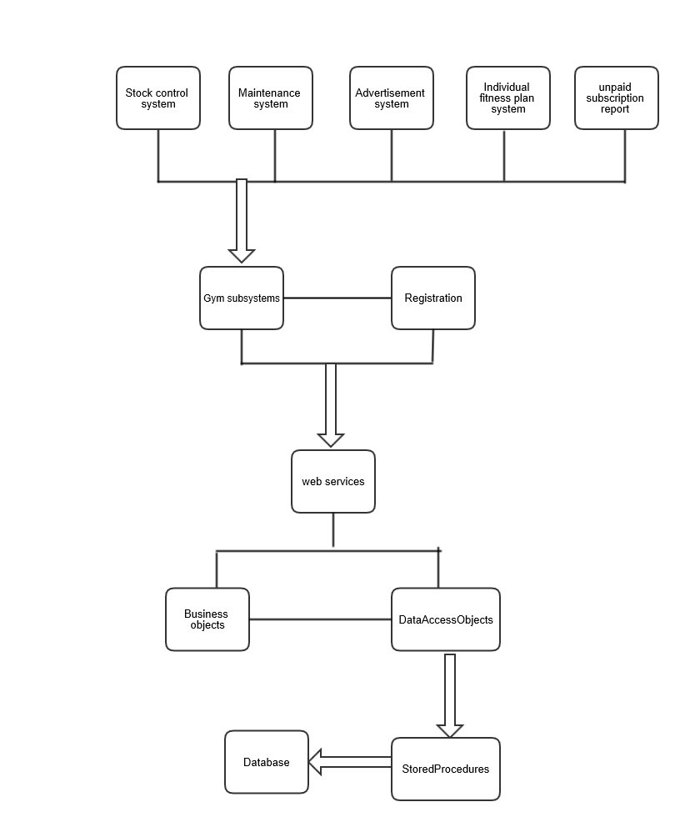

Figure 1.1

**Architecturally Significant Design Packages**

### *Application Layer*

The Application Layer provides the business logic and connects the Presentation Layer to the Database. The Application Layer is contained within the Web Services package. All communication with the Presentation layer is done through Web Services.

#### Web Services

This Package contains all of the Web Services that are provided by the application layer and consumed by the presentation layer

#### Business Objects

This package contains all of the objects which provide the Business logic for the system.

#### Data Access Objects (DAO)

This Package contains all of the objects which are used to communicate with the database. Each object contained in this package has a table or tables representing it in the database.

### *Data Layer*

The Data Layer consists of the MS SQL server 2000 database and the stored procedures contained within.

### *Presentation Layer*

The Presentation Layer is composed of two basic packages, Registration and Gym subsystems.

#### Gym Subsystems

##### Stock control system

This subsystem is responsible for recording the sale of food supplements, diet foods and fitness equipment to members.

##### Membership system

This subsystem is responsible for keeping track of the number of members the gym has and as well as updating the system when their all new members.

##### Marketing System

This subsystem is responsible for managing the advertisements in the system for instance membership promotion campaign.

##### Program system

These subsystems is responsible for providing members with necessary program information for instances program price, time, and instructor’s details and so on.

#### Registration

This subsystem contains the components for the registration of new accounts for new members.

# *Deployment View*

The perfect fitness online system is deployed on a single server hosting the database, webserver, and web services. Both clients and customers can connect using any web browsers through the internet. The service provider that hosts our website is Telkom.

# *Implementation View*

The perfect fitness online system will be implemented using a server based architecture and a star topology network.

*Star topology*

The star topology is one of the most commonly used network setups in any organization, with any device and computer being connected to a central device.

It will provide the fitness club with good performance, it will be reliable due to the fact that if one connection fails it doesn’t affect the others, it is easy to setup and maintain as well as easy to replace, install or remove host or other devices.

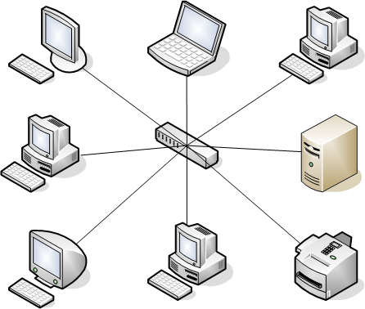

Figure 1.2

*Server based network*

This network model will permits the fitness club members to access and share resources that is centrally controlled, whereby resources and user logons will be controlled by a specialized network server.

This setup will provide the fitness club with improved collaboration for instance file sharing, remote access which will permit users to access data on the server without physically being in front of the system, server backups which will store muitple copies of the fitness club’s data on additional internal hard drives thus data can be quickly recovered if any thing goes wrong and enhanced security due to permission access based on usernames and passwords.

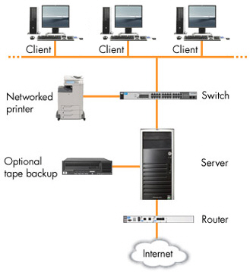

Figure 1.3

*Data View*

### *Data Layer*

The Data Layer consists of the MS SQL database. It provides logic that is directly related to the manipulation of data through the means of stored procedures. It is this layer that will communicate with the Web Services Layer through responding to SQL queries.

This diagram shows the database of the perfect fitness online sytem including all tables and relationships.

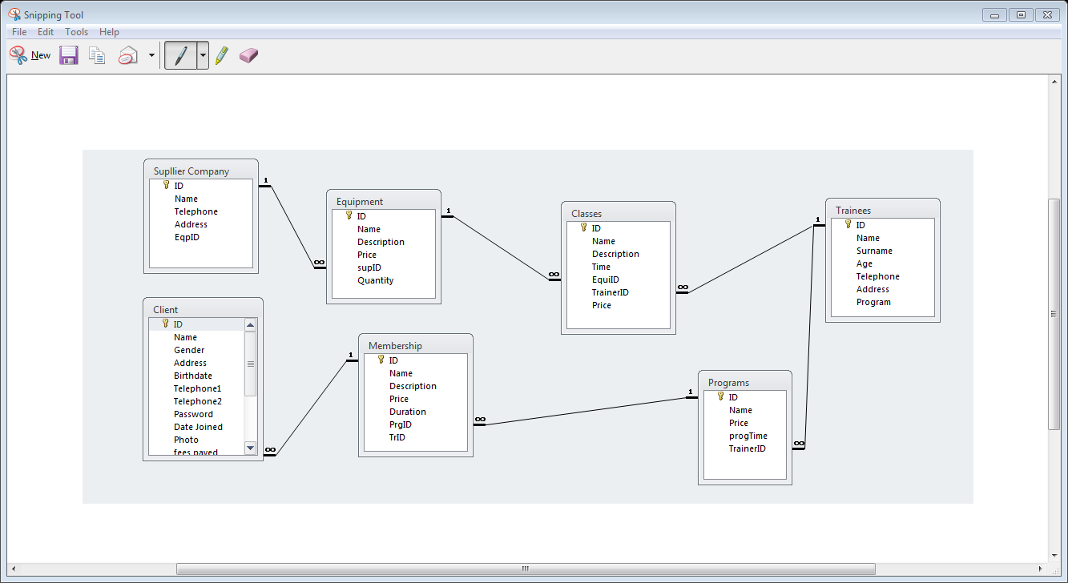

Accessories table

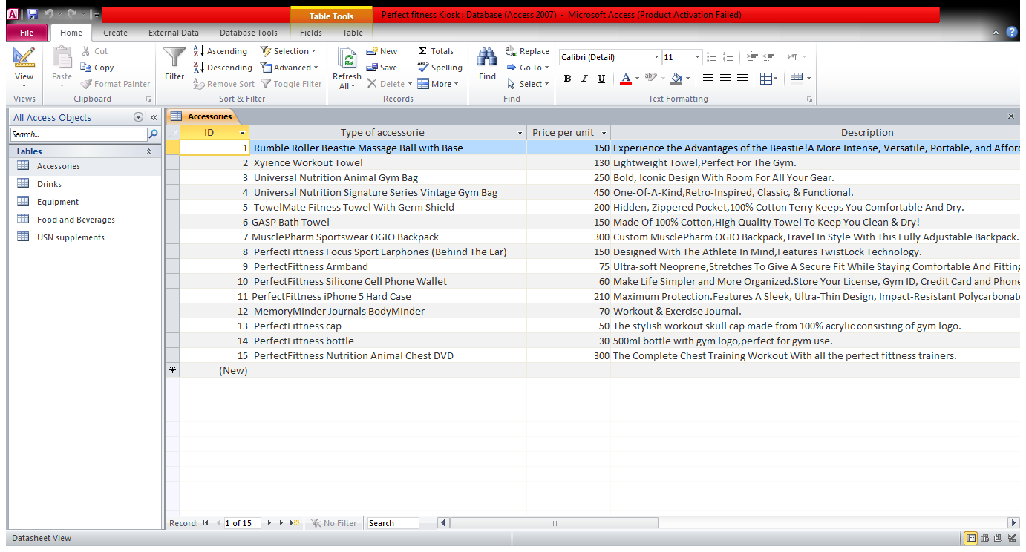

Drinks table

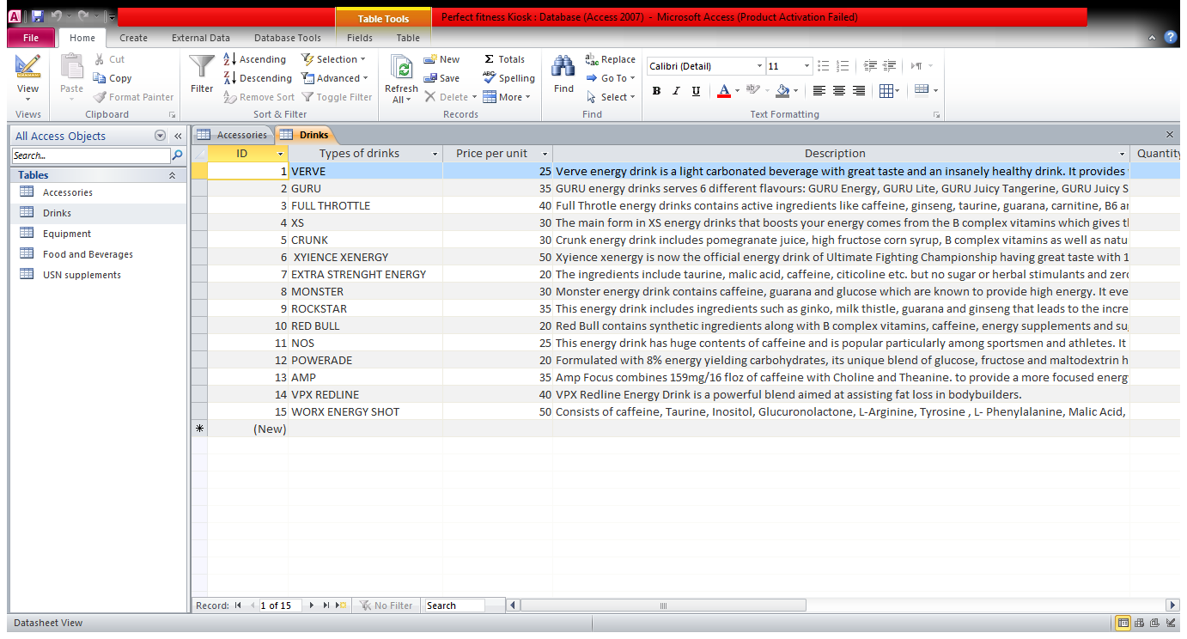

Equipment table

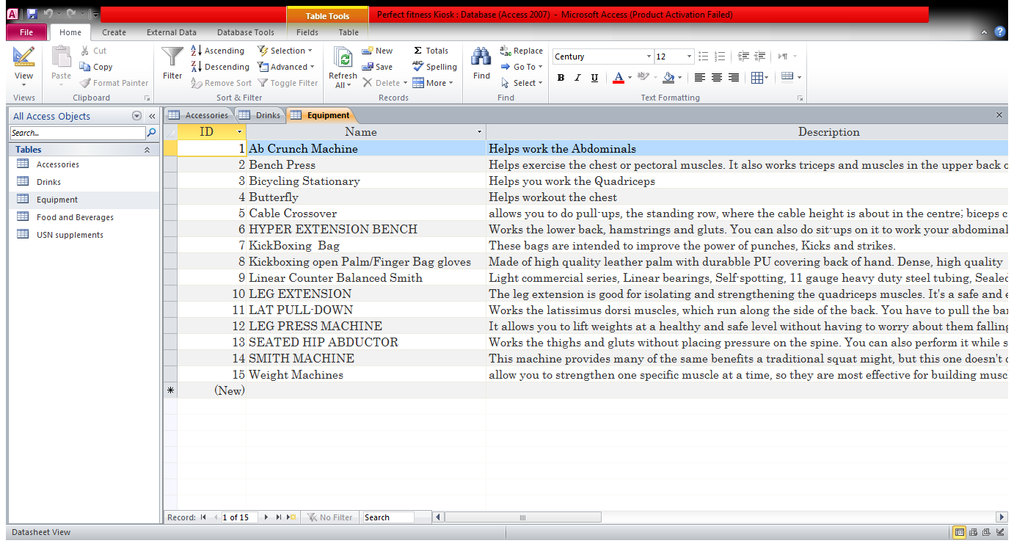

Food and Beverages table

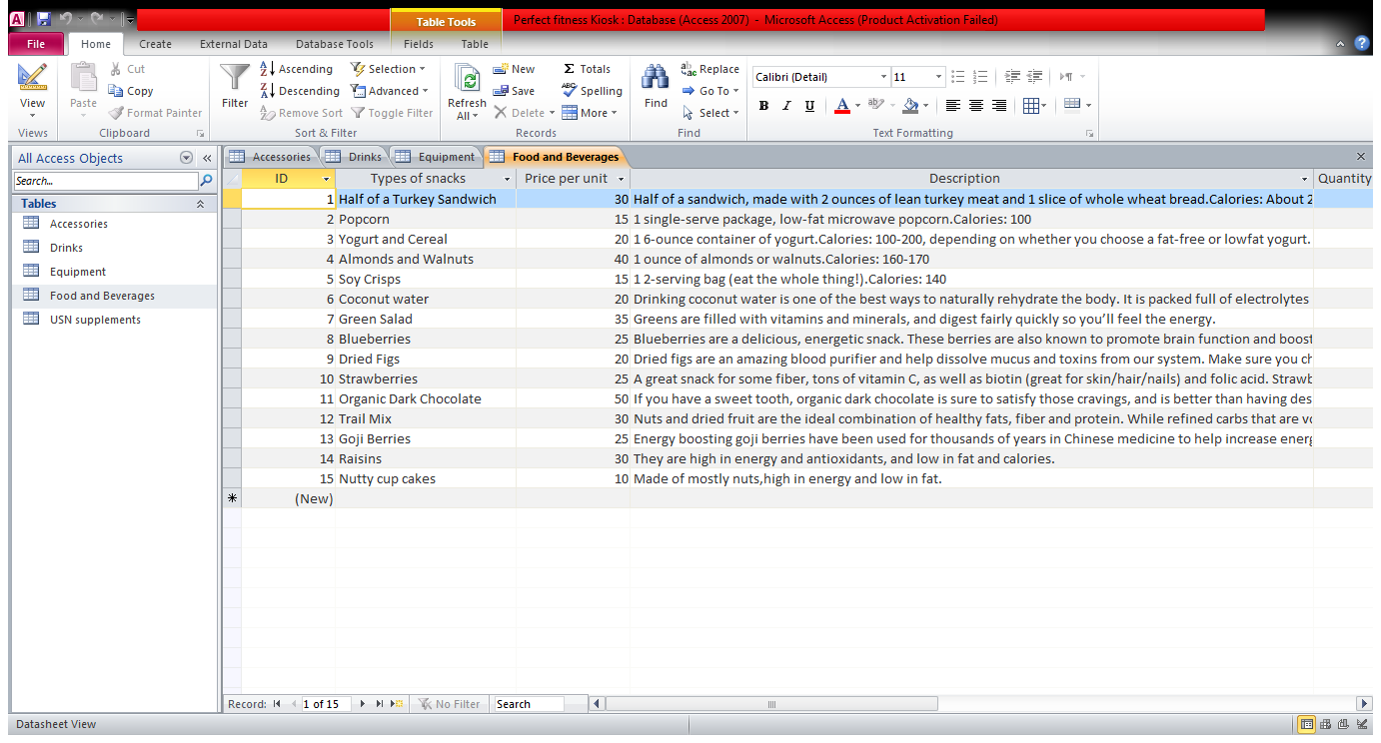

USN supplements

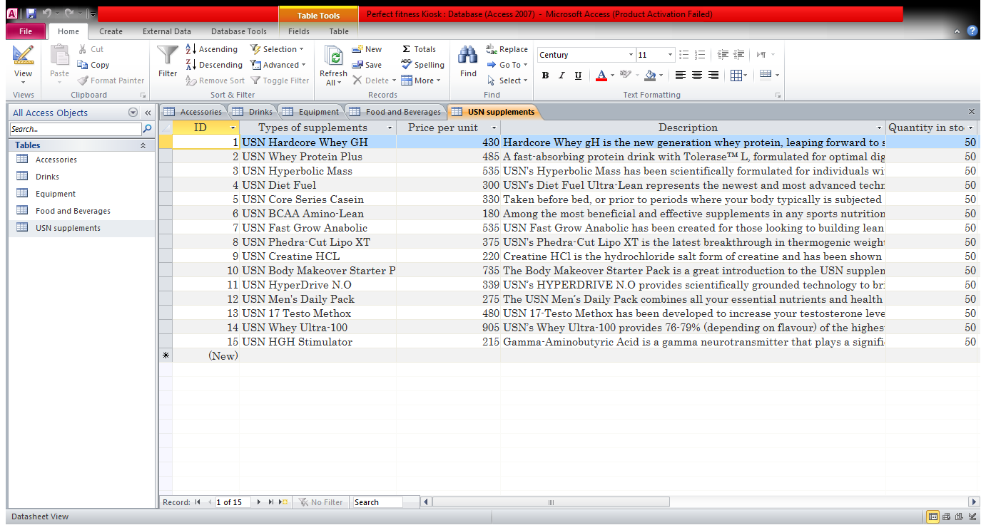

Trainees table

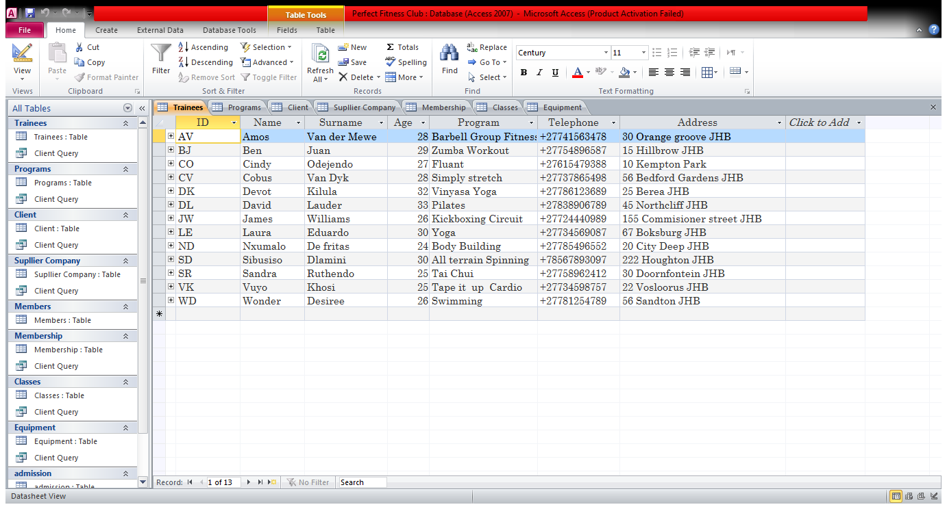

Programs table

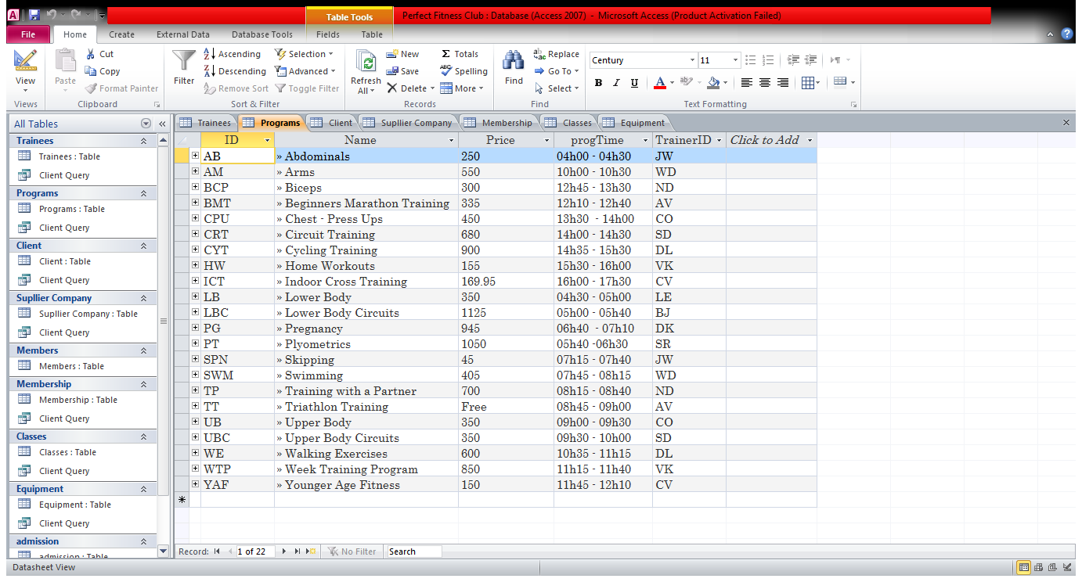

Suppliers table

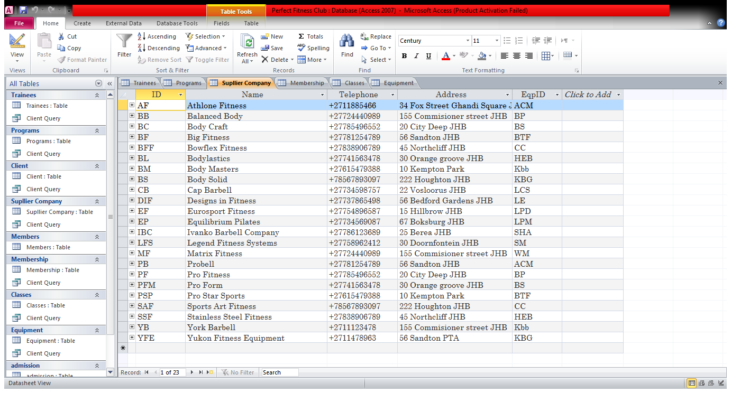

Memberships table

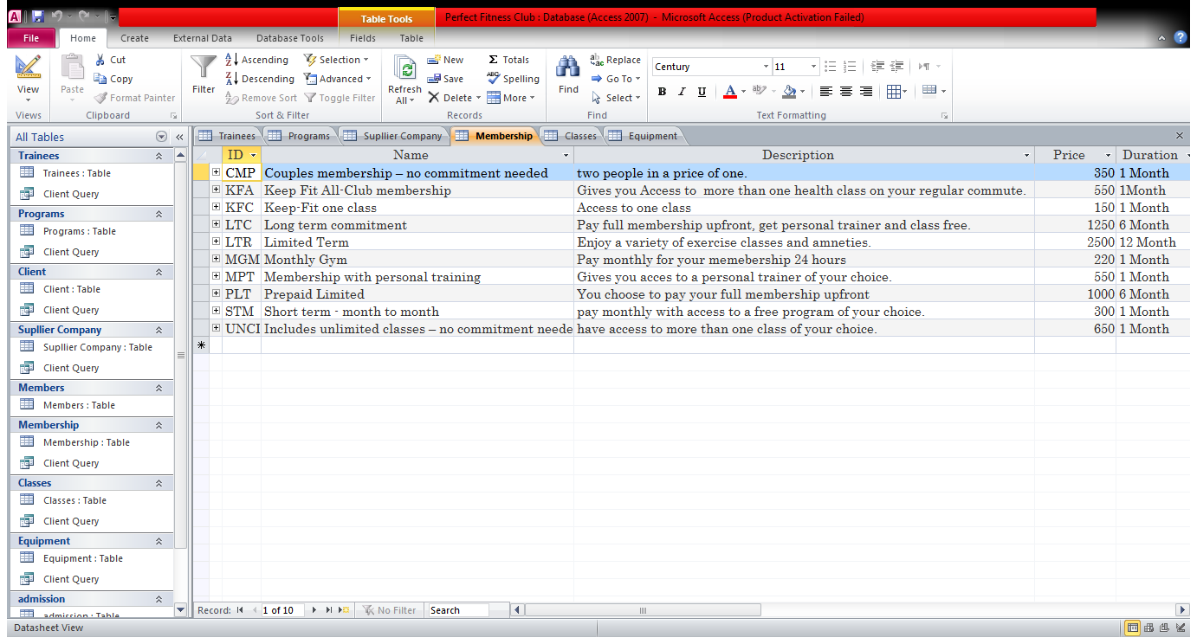

Classes table

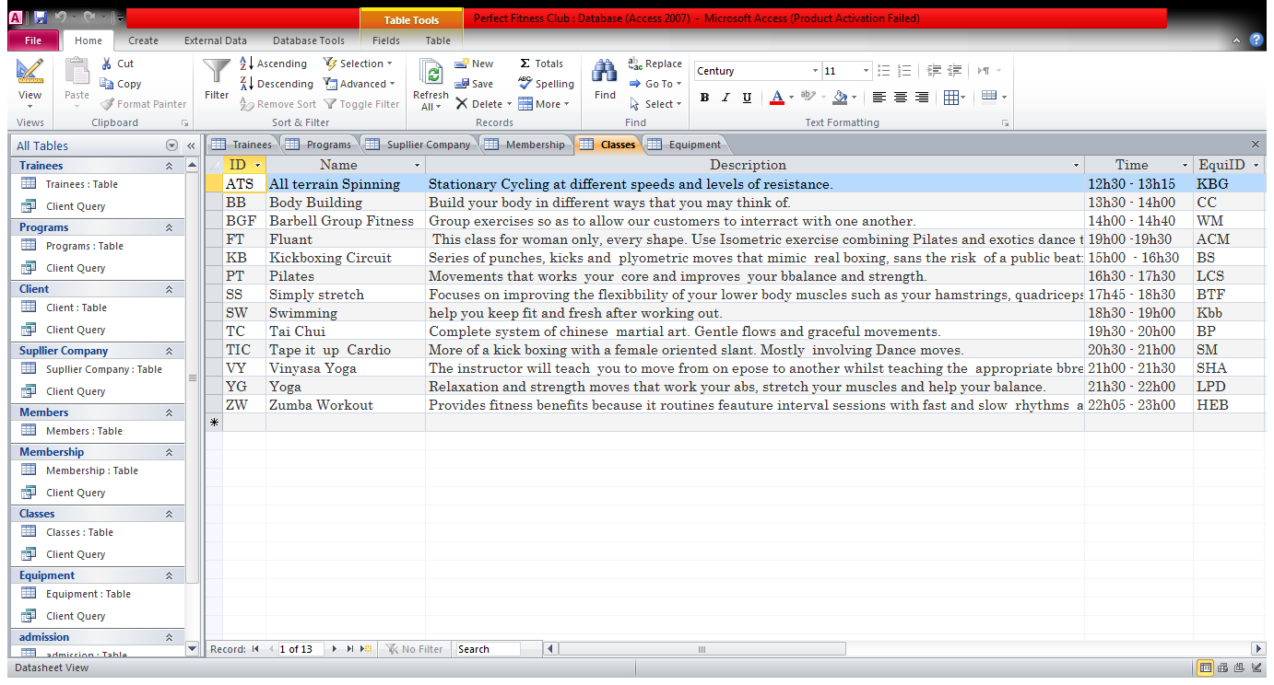

Equipment table

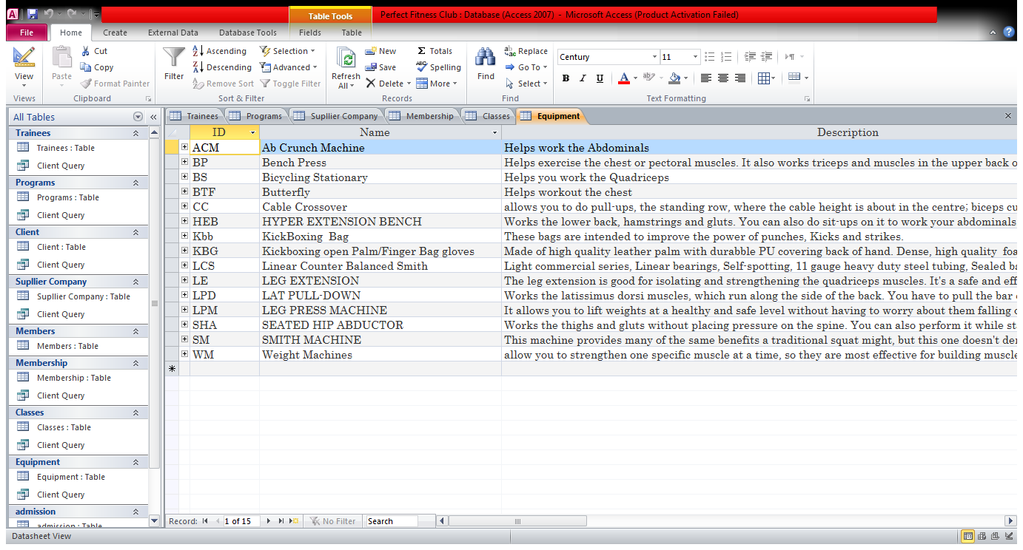

*Size and performance*

The system is designed to accomodate a large number of users and keep up with all user inputs and commands without affecting the system’s performance in any way.

1. **Project Implementation Report**

Introduction

Purpose of the project implementation report

The purpose of this report is to to evaluate the state of implementation of the project, the respect of the work plan, the methodologies used for the project and whether the project's objectives have been achieved.

Methodologies

The methodology we decided to use was the spiral life cycle model; the best thing about this model is its repetitive development in which the project goes through the same phases several times, each time becoming more and more complete.

This model consists of four stages:

* Planning
* Risk analysis
* Evaluation
* Engineering

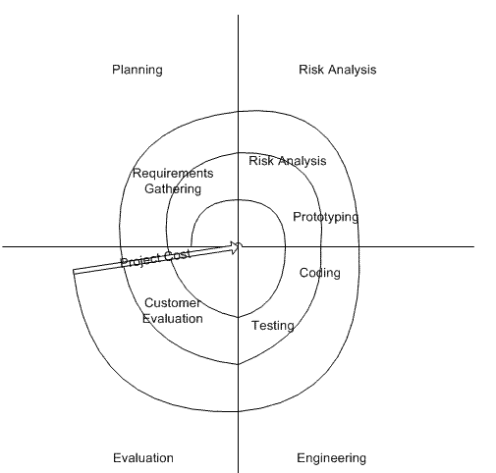

Figure 1.1

Steps taken in the spiral model for the fitness center:

1. The system requirements as well as the user requirements need to be defined in as much detail as possible. This involved a number of meetings with our client and the producing of a user requirements document.
2. A preliminary design is created for the online system.
3. The first prototype of the perfect fitness online system is constructed from the preliminary design, which was scaled-down, and represented only a few characteristics of the final product.
4. A second prototype was evolved using the following procedures:

* Evaluating the first prototype in terms of its strengths, weaknesses, and risks;
* Defining the requirements of the second prototype;
* Planning and designing the second prototype;
* Constructing and testing the second prototype.

1. The existing prototype is evaluated in the same manner as was the previous prototype.
2. The final system was then constructed, based on the refined prototype.
3. The final system then had to go through thorough evaluation and testing. And routine maintenance has to be carried out on a continuous basis.

Achievement of actions

Results achieved as compared to what was planned in the project proposal.

|  |  |  |  |
| --- | --- | --- | --- |
| Deliverable No: | Deliverable name: | Proposal date of completion: | Actual date of completion: |
| 1 | Requirements specifications | 06/03/2014 | 08/03/2014 |
| 2 | Project plan | 08/03/2014 | 08/03/2014 |
| 3 | Project costing | 10/03/2014 | 11/03/2014 |
| 4 | Risk analysis | 10/03/2014 | 11/03/2014 |
| 5 | Design reprt | 15/10/2014 | 15/10/2014 |
| 6 | User Guide | 15/10/2014 | 15/10/2014 |
| 7 | Operations and maintenance guide | 15/10/2014 | 16/10/2014 |
| 8 | Future enhancements | 16/10/2014 | 17/10/2014 |

Changes

One major change that took place was the change of the programming language used to create the program, intially the software developer started programming using C# then changed to Visual basics, as it was a lot more faster to program with, thus it saved an immense amount of time.

Project issues

A major issue we experienced was the client consistently changing the user requirements, the program changed many times until the final prototype.

Another issue was the continuous crashing of the database when linking it to the actual program.

Lessons learned

|  |  |  |  |  |
| --- | --- | --- | --- | --- |
| Lesson No: | Situation description | Outcome | Impact | Lesson learned |
| 1 | Started working on the system without fully understanding user requirements, it hopes to get the work done faster. | The prototype did not match the clients wants. | Program was restared. | Fully understand the user as well as the system requirements before attempting to do anything. |
| 2 | The database adminstrator developed a database for the system and sent it to the software developer without backing up of the database. | At some point the program did crash along with the database. | The database adminstrator had to start the database all over again,which was very time comsuming. | Always have a backup of everything you develop,to avoid restarting in case something goes wrong. |
| 3 | The software developer worked on the program for almost two months without speaking or meeting the client. | The client was not well pleased with what the developer had done so far. | Many things needed to be changed. | Even though you may think you are on the right track it is absolutely necessary to schedule meetings with your client so that they can view your progression. |

1. **User Manual**

**GENERAL INFORMATION**

General Information section explains in general terms the system and the purpose for which it is intended.

**System Overview**

Perfect fitness insight system is an application, which allows collecting information about a certain member willing to join the gym for certain period of time and other information from the gym. The application provides electronic version of form used in collecting the user information. The application saves data collected to database. Perfect fitness insight system operates on computers located at the gym.

**Organization of the Manual**

The user’s manual consists of five sections: General Information, System Summary, Getting Started, Using the System, and Reporting.

General Information section explains in general terms the system and the purpose for which it is intended.

System Summary section provides a general overview of the system. The summary outlines the uses of the system’s hardware and software requirements, system’s configuration, user access levels and system’s behavior in case of any contingencies.

Getting Started section explains how to install the perfect fitness insight system on the gym computers. The section presents briefly system menu.

Using The System section provides a detailed description of system functions.

Reporting section describes in what way information collected by the application are presented and how to access those information

**SYSTEM SUMMARY**

System Summary section provides a general overview of the system. The summary outlines the uses of the system’s hardware and software requirements, system’s configuration, user access levels and system’s behavior in case of any contingencies.

**System Configuration**

Perfect fitness insight system operates on computers with windows operating system. It is compatible with windows 93 and higher versions. The application requires a photo in order to save data in the database. The admin can access data saved in database after logging in to the system using the administrator credential. After installation on the device, Perfect fitness insight system can be used immediately without any further configuration.

**User Access Levels**

Only registered users are able to use the system and access the gym details saved data in the database.

**Contingencies**

In case of power outage data are not saved in internal memory of the operating device (except photos that are stored in external storage folder of the device).

**GETTING STARTED**

Getting Started section explains how to install the system on the computer. The section presents briefly system menu.

**Installation and Logging In**

The perfect fitness insight system version can be installed after clicking the .exe component. For specific instruction on how to install applications on specific device, refer to device’s manual. The user name is provided by the user and password is automatically generated while registering with the gym. The administrator’s name is “admin” and password is “admin”.

**System Menu**

Perfect fitness insight system is tabbed application, which consists of 8 tabs (Figure 1). The program tab represents programs that are offered by the gym. The instructor tab represents instructors that work for the gym. The membership tab has the membership types offered by the gym. The Equipment tab displays equipment that is in the gym. The inventory tab represents the suppliers of the gym. The Kiosk tab represents the stuffs that are sold in the gym. Client tab represent all the client details they have in the gym. The gym evaluation represents the gym total number and all the total cost of the gym. All the tabs have name at the bottom to allow distinguishing them easily.



**Figure 1. Tabs of Perfect fitness insight system**

**Program tab**

The Program tab (Figure 2) consists of a listbox displaying the program ID field and 4 textboxes that displays the name, price, time and the trainer’s ID. It is also possible to add new program and update certain program.

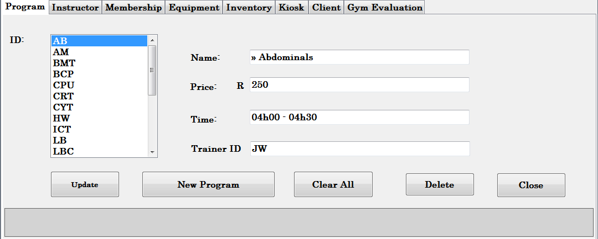

**Figure 2. Program tab**

**Instructor tab**

The Instructor tab (Figure 3) consists of 5 input fields containing information about instructors’ details.

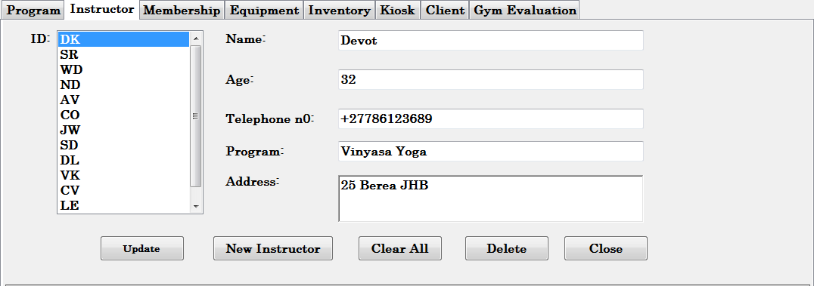

**Figure 3. Instructor tab**

**Membership tab**

The Membership tab (Figure 4) consists of 4 input fields containing information about membership details.

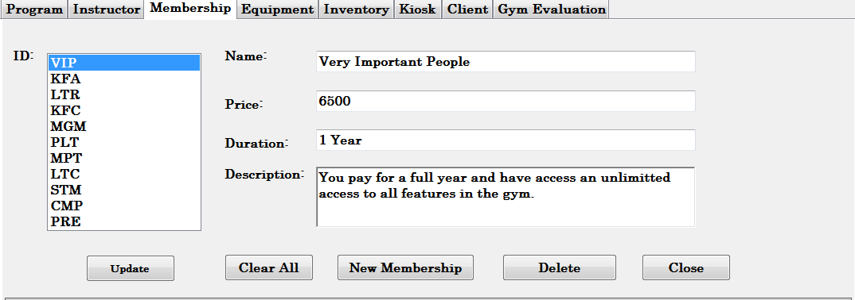

**Figure 4. Membership tab**

**Equipment tab**

The Membership tab (Figure 5) consists of 4 input fields containing information about the equipment. 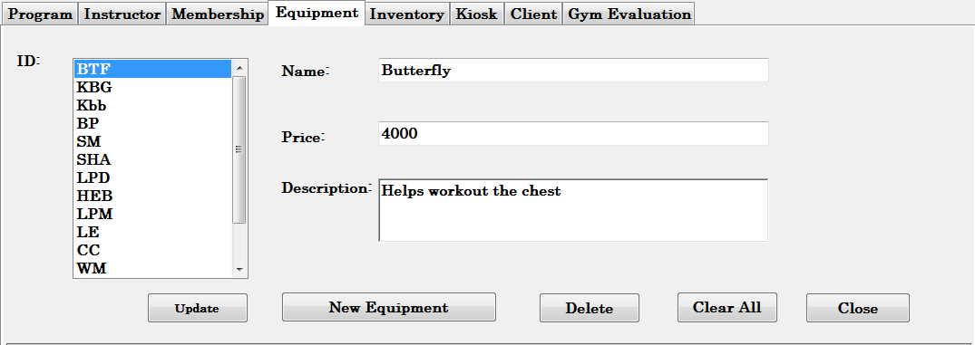**Figure 5. Equipment tab**

**Inventory tab**

The inventory tab (Figure 6) consists of 4 input fields containing information about the company that supplies them with equipment.

. 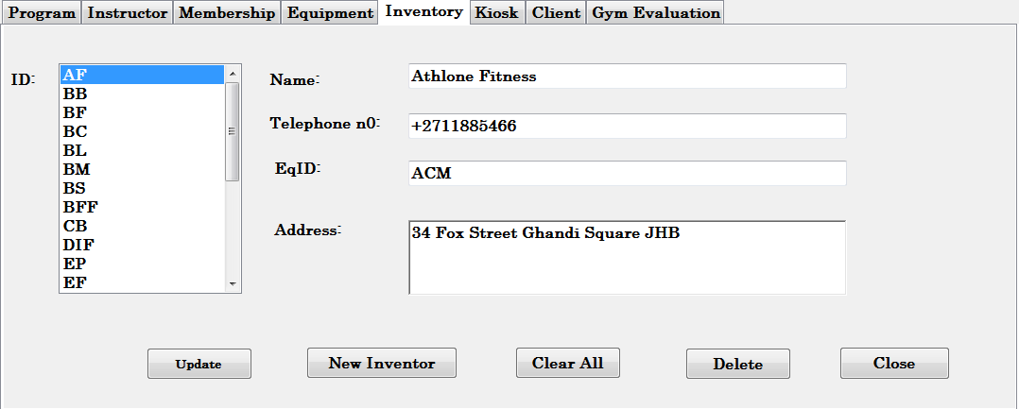

**Figure 6. Inventory tab**

**Kiosk tab**

The kiosk tab (Figure 7) consists of a tab which displays different categories(Equipment, USN Supplement, Drinks, Food & Beverages and Accessories) of items sold at the gym kiosk from which the tab

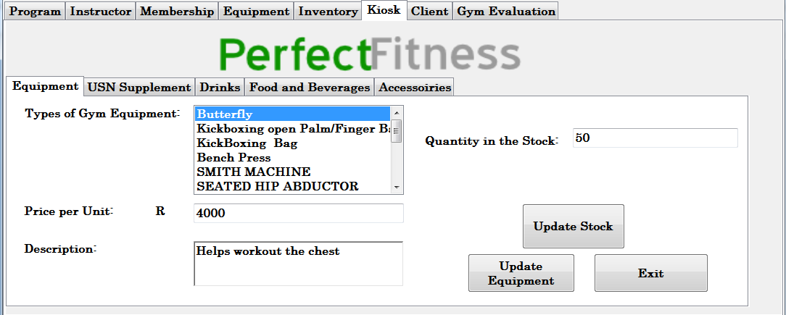

**Figure 7. Kiosk tab**

**Client tab**

The Client tab (Figure 7) consists of a table which displays the information of people registered with the gym of which the administrator can add new members, update, generate report, and delete.

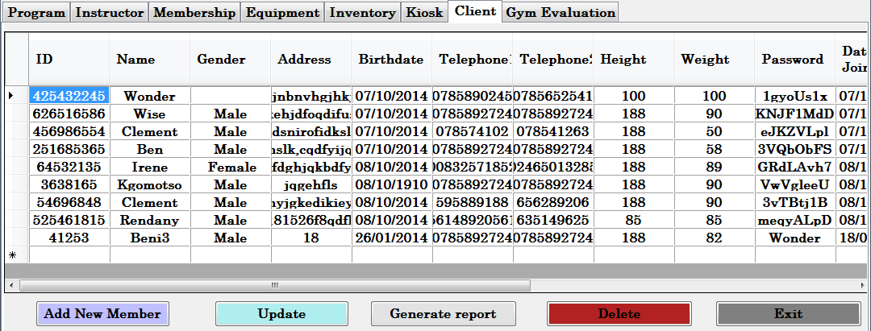

**Figure 7. Client tab**

**Gym Evaluation tab**

The Gym evaluation tab (Figure 8) consists of a tab which displays the monthly evaluation of the gym by calculating the sum of fees paid by their clients and client report (figure 9) enables the administrator to printout a report of a certain member.

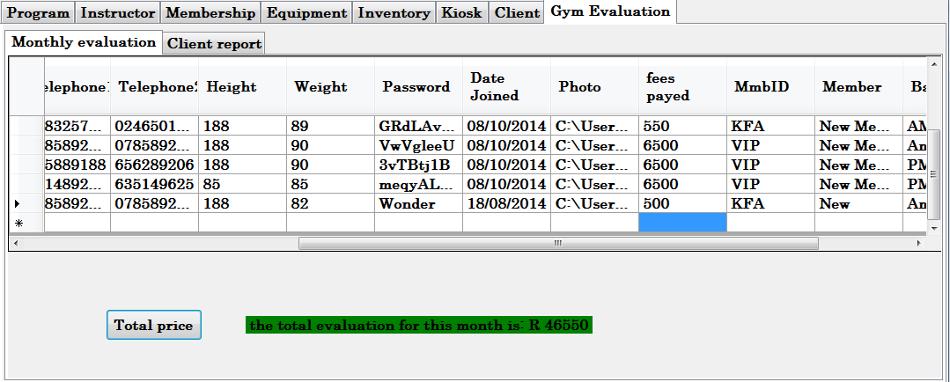

**Figure 8. gym evaluation tab**

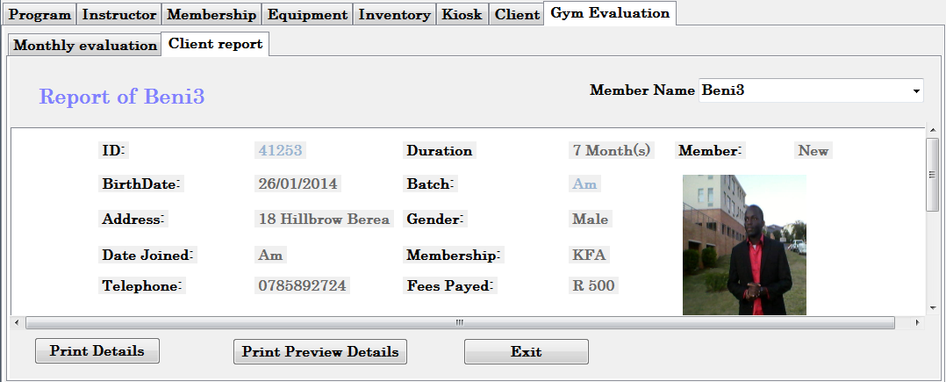

**Figure 9. Client report tab**

**Changing User ID and Password**

User ID and password can be changed only by contacting the gym administrator.

**Exit System**

Perfect Fitness insight system can be closed by clicking the exit button in the application

**USING THE SYSTEM**

This section provides a detailed description of system functions.

**Program tab**

The Program tab consists of 5 fields from which the first one displays the ID of the program, while the other 4 fields display the details of the selected program ID such as program name, price, time and the instructor ID.

Program ID field is a graphical control element that allows the user to select an item from a list. Name, price, time and the trainers’ ID are text input field where the program details are displayed.

**Instructor tab**

The Instructor tab consists of 6 input fields containing information about the instructors that work for the gym from which the first displays the instructor’s ID and the other 4 fields display the details of a selected instructor.

The Instructor ID field is a graphical control element that allows the user to select an instructor ID from a list. Name, age, telephone number, program and address are text input field where the instructor’s details are displayed.

**Membership tab**

The Membership tab consists of 5 fields from which the first one displays the ID of the program, while the other 4 fields display the details of the selected membership ID such as membership name, price, duration and description.

Membership ID field is a graphical control element that allows the user to select an item from a list. Name, price, duration and the membership description are text input field where the membership details are displayed.

**Equipment tab**

The Equipment tab consists of 4 fields from which the first on displays the ID of the equipment, while the other 3 fields display the details of the selected equipment ID such as equipment name, price and description.

Equipment ID field is a graphical control element that allows the user to select an item from a list. Name, price and description are text input field where the equipment details are displayed.

**Inventory tab**

The Inventory tab consists of 5 fields from which the first on displays the ID of the Inventory, while the other 3 fields display the details of the selected Inventory ID such as Company name, telephone, equipment ID and address.

Inventory ID field is a graphical control element that allows the user to select an item from a list. Name, telephone and address are text input field where the company details are displayed.

**Client tab**

The Client tab consists of table that displays the client information. Whereby the displayed information can be edited, deleted and generate the number of client in the gym.

**Gym evaluation tab**

The gym evaluation tab consists of 2 tabs which are Monthly evaluation and client report from which the monthly evaluation contains a table that displays the client information and a button that calculate the total price that the gym have made throughout and the client report consist displays a report of a selected client of which those details can be printed.

**Kiosk tab**

The kiosk consists of 2 different forms from which one is for the client and the other one is for the administrator.

The client form (figure 10) consists of 5 tabs equipment, USN Supplement, Drinks, Food & Beverages and Accessories.

The equipment tab (figure 10) allows the user to view the type of equipment sold at the kiosk, the price per unit of equipment, description of selected equipment, the quantity in stock and the quantity needed.

Client can buy single equipment at the time. After selecting the type of equipment and the quantity needed for that specific equipment, you check the total price and if satisfied with the price, you click on buy. If not, you cancel the transaction.

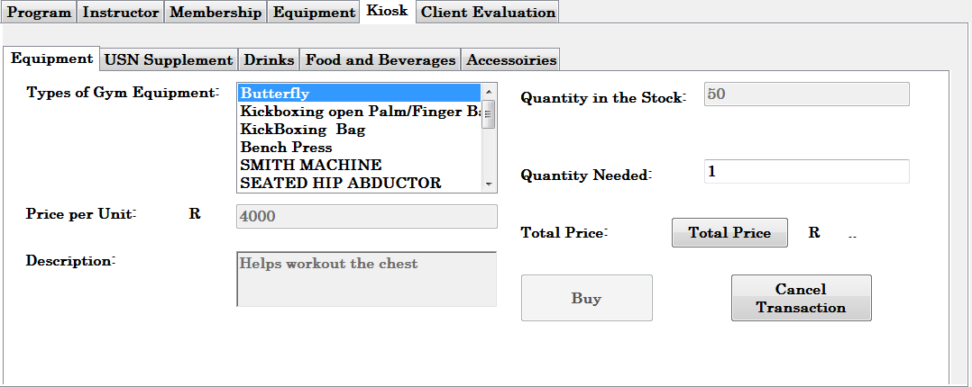

**Figure 10. Client kiosk tab**

With the USN supplement, drinks, food & beverages and accessories, client can buy more than one item of their choice by making use of the basket. When the client select a certain item, they click on the basket button, the price per unit will multiply itself by the quantity needed and then it will be saved in the listbox and the total price of everything will be displayed(Figure 11)

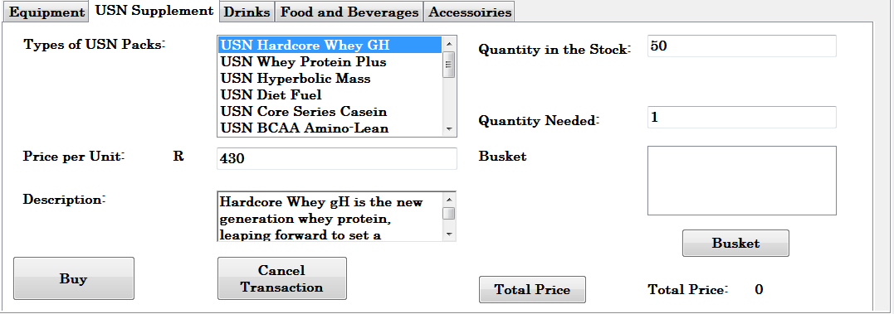

**Figure 11. Client kiosk tab**

The administrator form (figure 12) consists of 5 tabs equipment, USN Supplement, Drinks, Food & Beverages and Accessories.

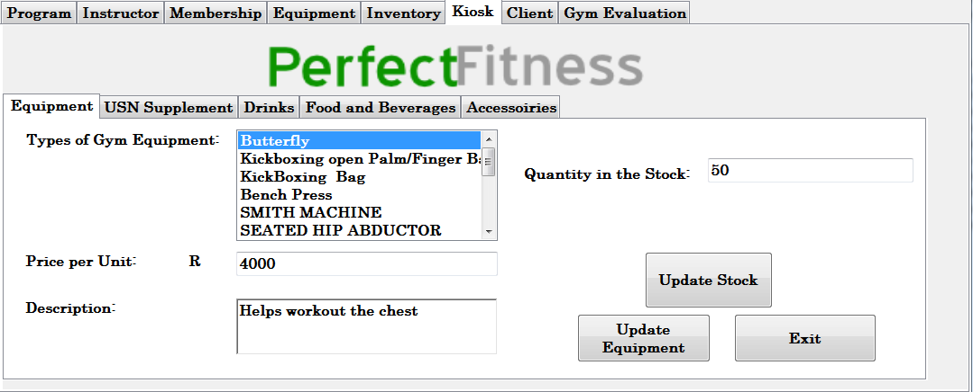

**Figure 12. Administrator kiosk tab**

The administrator can add new stock in the kiosk or update the stock in the kiosk.

**Special Instructions for Error Correction**

In case if the database cannot be used to retrieve client data, you may want to reboot your computer and restart the system. Note that that there might be a data overflow message that may appear time to time, by restarting the system, the database will be completely closed and once you restart the system again, it will surely be working fine.

**REPORTING**

Reporting section describes in what way information collected by the application are presented and how to access the information.

**Report Capabilities**

Information about each client is represented in the gym evaluation tab. The gym tab is located in administrator form.

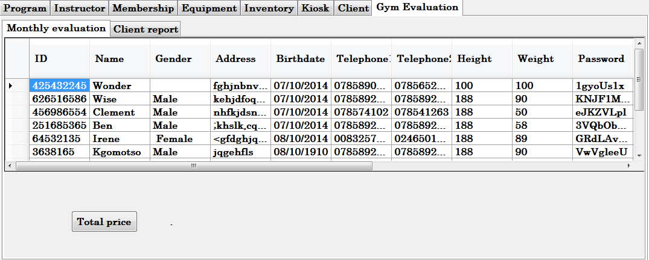

**Figure 13. Gym evaluation tab**

The gym evaluation tab consist of two tabs namely Monthly evaluation and Client report from which monthly evaluation (figure 13) consist of a table and button that displays the total price that the gym made with the number of client they have. The client report (figure 14) consist drop box which displays names of members that are registered with the gym.

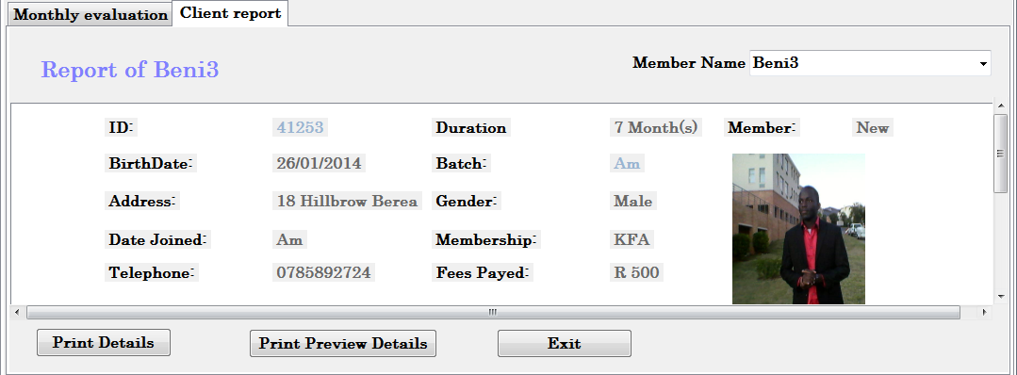

**Figure 14. Client report tab**

When specific member is selected from the drop box all information from the clients are displayed in the form. The form contains the name, birthdate, address, date joined, telephone, duration, batch, gender, membership, fees, member and the picture.

1. **OPERATION AND MAINTENACE GUIDE**

**Introduction**

Management information systems are systems that provide information needs to manage an organisation effectively and efficiently .These systems are considered one of the key components to any business objective an organisation would have .

Therefor the importance of maintaining the consistency direction towards the development ,the use of the system ,reviews and reports have to be an ongoing process within the organisation .The management information systems can be analysed and used on many levels of management within the organisation and it was development to support the long term strategic business objective related to the organisation .The gym’s MIS also supports everyday finances and accounting functions that will validate that control is maintained with the financial record data .

When assessing the risk vulnerability that a management information system will encounter one has to consider four important factors. These five factors are timeless ,accuracy ,consistency ,completeness and relevance .

**Timeless**

Information systems are designed with the intent to expedite reporting information ,the system should able to quickly collected ,edit and store data with no error encountered .

**Accuracy**

One of the most important factors is accuracy , a system must always be able to capture and produce data accurate at all times .A failure to produce accurate data can result in the downfall of any organisation .

**Consistency**

The systems should be consist will all it’s operation it conducts on a daily basis , because an enormous of data is being captured and stored the system may be come overloaded this can potential effect the consistency of the system .

**Completeness**

The candidate that participate in the decision making need to have a complete and pertinent information which summarised in a professional manner .These reports should focus on the overload of information .

**Relevance**

All the information that is given to management level must be relevant at all times ,all data that is irrelevant and inappropriate holds no value to the decision making phase .Providing the relevant information accelerates the process of identifying and solving the problem that has occurred .

**Objectives**

The operation and maintenance phase should consist of :

1 Monitoring the performance of the system .

2 Monitoring the all the security activity such as audits ,back ups and contingency planning

2 The management to alterations to the system to support the users .

3 Focusing on the end user through documentation and training .

The main aim of the operation and maintenance phase is to ensure the Management information system is fully functional and performance efficiently until the system malfunctions.

**Deliverables**

The SDLC can be used to successfully plan , execute and control Projects by providing an outline to ensure that all aspects of the project were defined planned and communicated .

|  |  |  |  |
| --- | --- | --- | --- |
| Deliverables | Goals | Developed by | Approved by |
| Performance reports-Track the routine metric as system performance indicator . | 1.Provide accurate reports on agreed upon performance measurements  2. Also include the key performance indicators . | System manager | Business owner |
| In-process reviews-This will formally report the health of the system ,it will consist of a summary of all the performance reports by these will be more formalized and developed quarterly . | 1.Provide the organisation head chair person with insight to the systems performance .  2.Include the results received from user ratification reviews . | System manager | Business owner |
| Implementation notification-The formal request for the approval for system changes that are made during the implementation phase . | 1.Mainly to have a formal request to have any system implantations . | Project manager | Business owner |
| Standard operating procedures-This will define how the system team users will conduct the business processes associated with the operation and maintenance of the system . | 1.Give clear and detailed guideline for the current and future business processes .  2.Provide a consistent execution of all business objectives .  3.Navigate the performance improvements and improve the results with the organisation . | System manager | Business owner |
| User Satisfaction Reviews-This will determine the current satisfaction rate that the user will encounter with the performance capabilities of the system . | 1.Conider the satisfaction from the users of the system . | System manager | Business owner |
| Disposition plan-will define how the termination of data will be conducted ,when will the termination of system occur and the disposition of the equipment . | 1.adress all the factors that have a direct function towards transferring and disposing of the systems data . | System manager | Business owner |
|  |  |  |  |

**Roles of participants**

The personnel that will participate with activities associated during this phase are listed below .The participants will need to conducts their duties effectively in order to ensure that maintenance of the system is achieved .

1. System manager

2. System team

3. Business owners

4. Project stakeholders

5. end users

**Review Phase**

The System manager will have to ensure that the following protocols are followed are completed .

1 The end users need s receive proper training in association with the system .

2 The system documentation needs to be complete and always available .

3 The system that is used is certified and accredited.

4 The system has been correctly deployed and is 100 % functional .

5 All the problems that were identified during the implementation phase were corrected .

**Conduct Risk management activities**

During the implementation phase the project manger will have to conduct risk management activities ,these activities are listed below :

1 Identification – identifying what potential risks that might affect the business objectives .

2 Risk analysis – Once the risks have been identified the system manager will have to conduct a quantitative and qualitative analysis of each risk .

3 Response Plan – The avoidance strategies that will be used in order to reduce the risk from occurring

4 Monitoring and control – Monitoring the risk/problem identified ,tracking it and identifying new problems that may occur within the system .

Monitoring Phase

Again the system has the responsibility to monitor the performance by collecting status data about :

1 All the chances that may be encountered with the baseline system performance .

2 Have alterations to management information .

3 Have activity progress with all status details .

4 Ensure that the activity’s that have been initiated are finished .

5 Have resources to the utilisation of data .

**Support systems operation**

The system is supported the by the system team and end users , as an important contribution of the data process on day to day operations .the systems operation manuals will define the duties ,activities and the responsible personnel for daily activities and these must be updated every time change occurs .

1 The guarantee that the system is available .

2 Monitoring and ensuring service levels objectives of the system ,while taking actions to reduced and deficiencies .

3 Constant monitoring the performance measurements ,system logs ,stats and the network factors that may effects the system .

4 Perform routines for backup and recovery procedures .

5 Ensuring that users received periodic training related to current and new process implementation of the system .

6 Create routines on physical security ,ensuring that users and staff members have the correct clearance and privilege access within the system.

7 Acquisition of the systems suppliers(e.g. network devices ,workstations ,cables) .

8 Ensure that is a protocol the protocol of testing contingency planning for data recovery .

The system manager will have access to reviews from reports gathered earlier on .These re documents will consist on of :

Date and time

Problem reporter

Problem description

Cause

Assigned developer

Resolution

Results

**Perform System maintenance .**

The system team and manager will have to have to continuously monitor the performance of the system in regards of it’s ability to function with no errors , the transaction rate and the hardware components that assist the software capabilities .

The system team will face daily operation that will require the team to identify and implemented minor changes to the systems in order for it to function efficiently and correctly .The system team must always document the changes that have been made during the daily process transactions with the system , and then follow Enforce system configurations .

The system manager may have changes to the systems hardware components if he/she see’s fit ,adding or removing any hardware devices that may have an impact to the systems performance .The manager how is not permitted to alter with the overall system that is implemented to reduce the risk of further damage .Documentation of any hardware enhancements need to be made and the system manager will have to follow the change management process to receive approval for the enhancement .

Review system performance with the users .

System mangers will have to routinely share reviews with the end user in order for them to be able to identify new problems within the system .The user satisfaction review may be included in this section as well as a customer satisfaction survey ,can carry feedback of the system to determine is the system is reliable or not .

The in in process review will also be conducted and during this process the system manager will evaluate the systems performance against the baseline performance ,the adaption to altering business needs and the new technologies available that may improve the overall system .

The organisation must create process improvement review board with will consist of the project stakeholders of all the groups that are directly impacted by the system .these reviews are to ensure that there is proper communication and decision making within the organisation .

**Preparation of the disposition plan .**

The termination of the system will be identified within the disposal plan ,it will also cover when the system will be terminated and whether the data within the system will be preserved or not .

**The important elements of the disposition include :**

1 Introduction – the scope of system or project is identified .

2 Notification - will cover the plan to notify the users of the system and other affect parties on the shut down of the system .

3 Data deposition – detailed plan of deleting or transferring the system data .

4 software disposition – detailed over view of deleting the software ,or transferring to other systems that have related documents .

5 System documentation disposition – the plan of deleting ,or transferring the system documents both hard copies and soft copies .

6 Equipment disposition – The plan that describes deleting ,or moving to the other systems concerning the hardware and other related equipment .

1. **project Evaluation report**

**WHAT IS A FINAL EVALUATION REPORT?**

The final evaluation report describes how you monitored and evaluated your project. It presents the findings, conclusions, and recommendations from a particular evaluation, including recommendations for how evaluation results can be used to guide program improvement and decision making. The evaluation report describes the focus on the process of implementation the system and impact it will have after the implementation has taken place, since this would be minimal after such a short time, accessing in particular the participatory approaches used to identify project beneficiaries and the team members’ and stakeholders’ role in implementing and monitoring the project. The evaluation purpose was to also focus on the Perfect Fitness online System by analysing the problems and issues faced during the development of the project and progress of the system through the whole entire design of the project as well as evaluating if the objectives and goals of the Perfect Fitness Online System were achieved.

## Reason for closing the project

The deadline of the project has been reached.

**Purpose of the final evaluation report**

* To assess the degree to which Perfect Fitness Online System project objectives were achieved.
* To document the lessons learned during the development of the Perfect Fitness Online System.
* To provide recommendations for the Perfect Fitness Online System project development and improvement.
* To examine the changes that resulted from doing the Perfect Fitness Online System project.
* To provide input to guide decision making for the upcoming renewal and extension of the Perfect Fitness Online System project funding.

**Perfect Fitness Online System Evaluation Achievement**

* Record member details, payment of subscription, produce annual membership bill as well as overdue report for manager on unpaid subscriptions.
* Record sale of food supplements, diet foods and fitness equipment to members and this information had to form part of the member record.
* Record individual fitness plans for members, goals and targets had to be identified to be met with the plan. Maintaining an updated session record of members’ progress in their plan against their goals/targets. The manager had to be provided with a review reminder plan, after each 5 sessions.
* Statistical information o the relative of performance members against their fitness plans had to be maintained to show the effectiveness of the club. Statistics on usage levels had to be produced; additional member spending and membership levels, as an aid to future planning and promotions also had to be produced.
* Marketing plan and membership promotion campaign had to be developed based o the above goals given. Case studies using anonymised data or with member permission, as promotional material had to also be developed.

**Stakeholders who were involved in the project**

* Project Director: Renard
* Project Manager: Beni Iyaka
* Project Customer: Clement Kapp
* Project Group: Irene, Dane, Daniel and Kgomotso

**Evaluation Type**

The type of evaluation report being used is the summative report. The report is an overall assessment and evaluation of the project’s effectiveness and achievements of the Perfect Fitness Online System. The report reveals whether the Perfect Fitness Online System did what it was designed to do and provides information for future planning and decisions.

**The Perfect Fitness Online System Methods and Tools**

|  |  |
| --- | --- |
| **Methods and Tools:** | Interview |
| **How (or where) was the tool used?** | The tool was performed at the Perfect Fitness Gym |
| **From whom or where was the data gathered (i.e., source of data)?** | The data was gathered from the Client who is the manager of the gym and members of the gym |
| **What are the main results obtained from the data?** | Qualitative Data |

|  |  |
| --- | --- |
| **Methods and Tools:** | Questionaires |
| **How (or where) was the tool used?** | The tool was performed at the Perfect Fitness Gym |
| **From whom or where was the data gathered (i.e., source of data)?** | The data was gathered from the Client ad the members of the gym |
| **What are the main results obtained from the data?** | Qualitative Data |

|  |  |
| --- | --- |
| **Methods and Tools:** | Surveys |
| **How (or where) was the tool used?** | The tool was performed at the Perfect Fitness Gym |
| **From whom or where was the data gathered (i.e., source of data)?** | The data was gathered from the Client and the members of the gym |
| **What are the main results obtained from the data?** | Qualitative Data |

|  |  |
| --- | --- |
| **Methods and Tools:** | Focus Groups |
| **How (or where) was the tool used?** | The tool was performed at Perfect Fitness Gym |
| **From whom or where was the data gathered (i.e., source of data)?** | The data was gathered from the Client and the memebers of the gym |
| **What are the main results obtained from the data?** | Qualitative Data |

|  |  |
| --- | --- |
| **Methods and Tools:** | Prototyping |
| **How (or where) was the tool used?** | The tool was performed at the Perfect Fitness Gym |
| **From whom or where was the data gathered (i.e., source of data)?** | The data was gathered from the Client and the memebers of the gym |
| **What are the main results obtained from the data?** | Qualitative Data |

**Evaluation Questions**

**Questions related to process of the online system**

|  |  |
| --- | --- |
| **Question** | **Answer** |
| 1. Did we properly identify the problems of the online system? | The requirement of the project were defined clearly and were well understood by the project team and everyone else involved during the process of the project |
| 2. Is the project reaching the intended target population? | Yes, as the client is satistified with end results of the project |
| 3. How satisfied are the participants with their involvement in this project? | The project team are satisfied that the client approves of the project during and after the development of the project |
| 4. How should the planned activities be modified to work better? | By appliying the lessons learned in order during the development of the project to avoid any repeating mistakes that were made. |
| 5. What lessons can we learn from the way in which the project is unfolding? | Working with the project requires a lot of patience and passion in order to achieve the required results. |

**Questions related to outputs of the Perfect Fitness Online System**

|  |  |
| --- | --- |
| **Questions** | **Answers** |
| 1. Is the project providing the planned services? | Yes |
| 2. Are the activities leading to the expected products? | Yes |
| 3. Are there any unexpected products? | No |

**Questions related to outcomes/impacts of the Perfect Fitness Online System**

|  |  |
| --- | --- |
| **Questions** | **Answers** |
| 1. What are the effects of the project on the Perfect Fitness gym? | The effect of the project was positive, the online system was tested and works appropriately relating to the specified requirement |
| 2. Did we experience any changes as a result of the project? | Yes, more report had to be made asuch as the financial report, change of the database and program. |
| 3. What could be the long-term impacts of this work? | The oline system to be updated or upgraded with time. |
| 4. Are there any other related needs that have arisen that the project did not address? | No |

**Questions related to alternatives and lessons learned**

|  |  |
| --- | --- |
| **Questions** | **Answers** |
| 1. What could have been done differently to complete the project more effectively? | To pan ahead and manage time so as to keep on schedule |
| 2. What key changes should be made to the project to enhance achievement of objectives? | To improve more on the login page ad register of the memebers. |
| 3. What are the lessons learned for the future? | Always have a backup of everything you develop,to avoid restarting in case something goes wrong, to always uderstand the user requirement fully before the planning should take place. |
| 4. What outcomes should be considered if an organization wants to repeat this or conduct a similar project? | To always evaluate the project prototype to see if any changes need to be made or if any more ideas has to be implemeted. |

**Project Objectives or Goals:**

* Record member details, payment of subscription, produce annual membership bill as well as overdue report for manager on unpaid subscriptions.
* Record sale of food supplements, diet foods and fitness equipment to members and this information had to form part of the member record.
* Record individual fitness plans for members, goals and targets had to be identified to be met with the plan. Maintaining an updated session record of members’ progress in their plan against their goals/targets. The manager had to be provided with a review reminder plan, after each 5 sessions.
* Statistical information o the relative of performance members against their fitness plans had to be maintained to show the effectiveness of the club. Statistics on usage levels had to be produced; additional member spending and membership levels, as an aid to future planning and promotions also had to be produced.
* Marketing plan and membership promotion campaign had to be developed based o the above goals given. Case studies using anonymized data or with member permission, as promotional material had to also be developed.

**Project Activities**

Provide a list of project activities that were completed and their outputs.

* A registration page was designed and developed for users to register the membership details with a printed password once successfully registered.
* A login page for members to sign in so as to have access to the websites in order to explore and exploit all the information available on the websites.
* The database was designed to store members details, membership, the type of program and classes members are looking for as well as the food supplement and diet food which were also included in the Kiosk.
* Reports were developed on the websites that allows the manager to view the financial report, member’s reports as well as receipt reports.

**Project Outcomes**

**Unplaned Outcomes:**

* The risk of the online system was not carefully measured and that resulted in the program crashing along with the database.
* The online system prototype did not fully match the clients requirement.
* The client was not well pleased with the program

**Planned Outcomes:**

* Login Page
* Database of the online system
* Registry page
* Kiosk
* Membership type
* Payment of subscription
* Reports for manager
* Reminder review plan
* Measuring of performance
* Marketing plan

***Conclusions***

The report evaluated everything that had to be completed during the developement of the project. The online system allows members of the gym to perform the objectives required such as registering online to be members of the Perfect Fitness gym, thus allowing them to sign in so as to view the information provided for the gym. The online system allows the manager to prints financial report since members can pay a online subscription for an application fee and the type of memebership the members chose.

***Project Evaluation Sprints***

|  |  |  |
| --- | --- | --- |
| Task | Days | Hours |
| Objectives | 2 | 1 |
| Activities | 1 | 1 |
| Outcomes | 1 | 1 |
| Evaluation Questions | 1 | 1 |
| Methods and tools | 2 | 1 |
| Total | 7 | 5 |

Project Acceptance Plan

Approver for:

Date

Approver for:

Date

Project Manager Approval:

Date